Drawn to the Light Press

Issue 17

Spring 2026

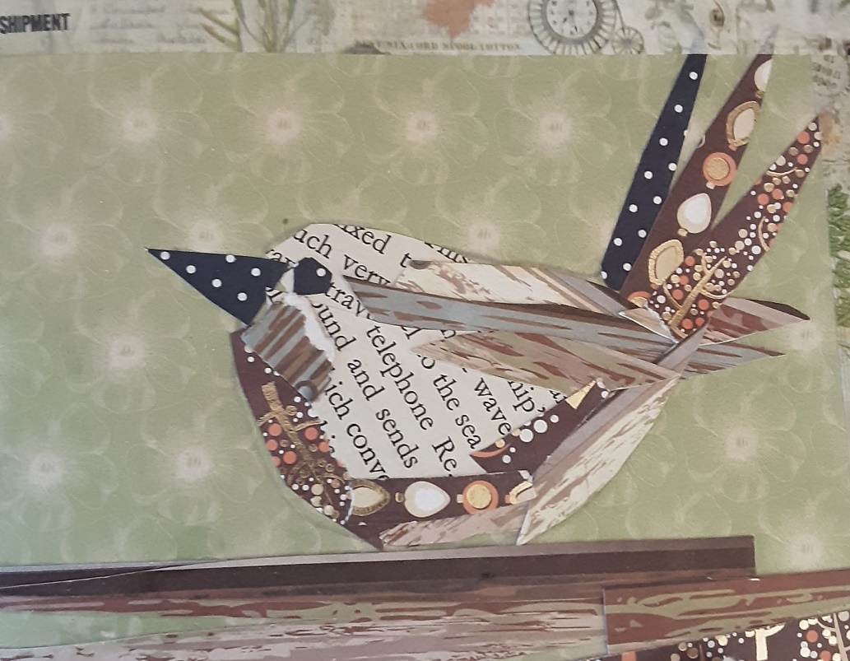

Wren Maire Morrissey Cummins

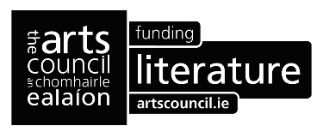

Patrons: Anthony Wade
Arthur Broomfield
Attracta Fahy
James Finnegan
Simon Lewis
Mary Lee




Editor: Orla Fay
Published by Drawn to the Light Press
ISSN 2737-7768
Next issue: June 2026
https://drawntothelightpress.com
Twitter: @DrawnPress
Instagram: @drawntothelightpress
Facebook: @drawnpress22
Drawn to the Light Press is edited, designed, and produced by Orla Fay.
Cover design Wren by Maire Morrissey Cummins.
The works included in this issue are copyright of the poets and artists ©2026 and may not be reproduced or changed in any way without the permission of the individual author.
Drawn to the Light Press is ©2026 of the editor.
All rights reserved.

Contents
First Day of Spring |  | Faye Boland | 6
Dalgan Snowdrops |  | Orla Fay | 8
Waiting for Snowdrops |  | Rosie Aziz | 9
To a Rag Tree |  | Patrick Deeley | 10
April |  | Martina Madden | 11
Lost Scarves |  | Simon Wilson | 12
Shifting |  | Tim Dwyer | 14
This Beautiful Pair |  | Chelsea Bright | 15
Recurring Resilience |  | Finn Cassidy | 16
Mulholland Drive |  | Darren Donohoe | 17
Daffodils |  | Teresa O’Connor Diskin | 19
A Little Gold Goes a Long Way |  | Lynda Tavakoli | 20
The Crozier Stage |  | Gerard Walsh | 21
Phenology |  | Judy Sutherland | 22
Oakwood’s Ethan |  | PD Lyons | 23
Spring |  | Giulia NíChonmara | 24
Uprising |  | Annie Egan | 25
Ushers |  | Anne Donnellan | 26
Bridget and the Bananas |  | Philip Quirke | 27
Petals |  | Paul Bavister | 28
February, early |  | Olga Dermott-Bond | 29
First Reflections |  | Lynda Tavakoli | 30
“My” Tree |  | Kathleen Cain | 31
A Winter Tree Toward Spring |  | Ignatius Lally | 33
On a Sunday Morning |  | Paudrig Lee | 34
Bearing Witness |  | Nicki Griffin | 35
Release |  | Mollie Berry | 36
Foothold |  | Amanda Shannon | 37
The Clouds I Recall |  | Rachel Roberts | 38
My Year with the Hare | Sandra van Beurden Hopkins |  | 39
Incantation |  | Kevin Dowling | 41
Crimson |  | Joanne Draper | 42
Little Fires of Brigid Poetry Competition Winners |  |  | 43
What Name Shall We Give The Baby |  | Nollaig Rowan | 44
So, tell me |  | Maria Hoey | 46
Bonfire |  | Stephen Brock | 48
Notes on Contributors |  |  | 50

Editorial

Welcome to issue 17 on this first day of March 2026. Spring has sprung and the sunlight is stronger and more giving, the daffodils bask in its nourishment. Last night I was dreaming of cherry blossoms and soon they will be sweeping their way to us on April breeze. St. Patrick’s Day and Easter are just around the corner, and what too of May and her glamour.
I picture the grasses growing tall here by the glassy River Boyne and the whiteness coming upon the hawthorn trees. I see swans and blue skies, dark swallows, bright mornings and longer days, greenery that grows like fire.
Thanks again to everyone who contributed to the magazine and to Maire Morrissey Cummins for Wren.
Congratulations to The Little Fires of Brigid Poetry Competition Winners 2026

Overall Winning Poem – What Name Shall We Give The Baby by Nollaig Rowan

Joint Runners-Up

So, tell me by Maria Hoey

&

Bonfire by Stephen Brock

Orla Fay 01/03/2026

First Day of Spring

A girl with a bike
makes figures of eight

as I watch from the
step of the house.

A girl with a smile
waves as she cycles

the narrow road
shadowed by forest.

On the first day of sunlight
camelias are budding,

daffodils push through the soil.
The air is alive

with plans and new growth,
leaves twitch in a zephyr,

the bay is serene.
People walk lightly,

sun freckling their faces,
bicycles creak as they pass.

Blackbirds are chirping
in trees that are leafing,

each person I see has a smile.
On the first day of spring

a girl with a rope
nooses herself to a branch

and now she is hanging
where blackbirds are singing

their hymn to the heavens
that winter has ended.

Faye Boland

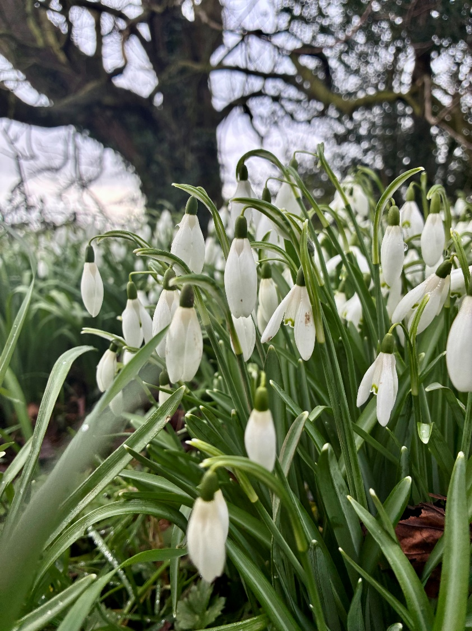

Dalgan Snowdrops Orla Fay

Waiting for Snowdrops

By Thursday,
I’ll be waiting for the snowdrops to arrive.
But the bed is stiff, and my mouth is dry,
and all the kitchen windows
are condensed with cold.
I’ll light candles merely to seem alive.

By Thursday,
I’ll be writing letters to the postman, eating
away at picture frames. We’re keeping
up appearances. Family toasts
the new year, and I cast my silent vote
to hide the fact that I’m not sleeping.

By Thursday,
I’ll drain these throw away resolutions
down the sink. Steep in the blow of confusion
instead. Perhaps when I lie awake
I’ll have finally earned my place
rather than just inspecting the bruising.

By Thursday,
I’ll dig up what’s left of the snowdrops,
and watch dawn drench into rooftops.
Soft rain will thaw the soil
as crocuses brave the garden trail.
Someday, I’ll brush sunlight with my fingertips.

Rosie Aziz

To a Rag Tree

Out beyond the beaten path

my words tip up the air

by the way they sway and flutter.

If the wind strews them

asunder, or they run

with each thunder shower,

surely this is what I intend:

that they utter me

down to the ground, in

and out of my tree. Regaling

spirits high and low,

tapping into the local powers –

and even if I grow

gnarled in hand and foot,

with thickenings

gathered at my neck and waist,

with hobbled heart

and desiccated brow,

I would still have the poem say:

there he leaps away,

the child I will always be –

through grace and give

of greening branches

he dances, who prompted me.

Patrick Deeley
April

Bluebells march in swathes over woodland
floors, decorating with sky as they go.

Thirty diamond encrusted days, showers
prepping the ground for blooming May.

Romans no longer chant ‘Aprilis, Aprilis’, beating
on leather strap shields to herald the re-awakening.

The opening Zodiac Aries, motivated, confident,
passionate, enters the sun, begins its ecliptic path.

April holds its fools briefly, concentrates on daisy bouquets.

Martina Madden

Lost Scarves
Blossom flares—
like lost scarves tossed
into the sun’s slow
spill across the grove.
Somewhere,
a blackbird etches
its calls
into the morning wake.
The sky—
still stitched with night—
tacks itself apart.
No one watches.
I stir—
snagged,
tight-chested
on time’s short hem—
before spring,
barefoot and forgotten,
lifts a finger to my lips,
traces pollen on my throat,
and floats a new air onto my skin.

I am draped in wonder…

cradled in a shallow of light,
damp earth beneath my soles:

before being,
as if pain had never spoken.

Simon Willson

Shifting

Big news along the shore—
absent for weeks, the brent geese
are passing through
on their migration north,
and the faces of the small gulls
have darkened again.
Spring.

Daylight grows longer,
the evenings milder
and the street pigeons,
seemingly out of place,
peck with gusto among
the briny pebbles revealed
by the receding tide.

Tim Dwyer

This Beautiful Pair

Two swans flying over a car park.
Four wings spread wide, white
swooping as they soar through the sky
and gracefully descend,
landing on orange flippers,
their heads held high, surveying the
empty football pitch marked out in lines
of white. Beating and buffeting
the early March air,
avoiding the dark feathers of a passing, confused crow,
wondering why this beautiful pair are so far
from the lake. They nod to one another,
thinking the same thought as their feet
leave the damp earth and fall back towards their chests
like a foetus trying to find more space, ensconced in a womb,
letting their wings elongate, two white bars rippling,
rising in the grey sky, higher than the greening hedges
and back down, at the abandoned goalposts,
trying to remember where they last saw water.

Chelsea Bright

Recurring Resilience
Darkening days beckon dark demons' old heckles.
Dormant during spring's surge, and summer's splurge,
they resurrect in Samhain's veil-flaying foliage.
I fear their presence. I search skywards for sun-swords,
one escapes its scabbard of suffocating clouds,
it won't slay the murmurings of reawoken ghosts,
but help keep at bay their recurring seasons of echoes,
their spectral shadows stare back, cackle-crack,
hiss and spit through winter's fall-coloured flames -
I'm safe in brave fire's light - I drift in and out of sleep
until I find myself standing afresh in February frost,
I cast cold cinders to fruit-rot, rooted in soil and time,
a shift disperses in an Imbolc breath of fresh-fiery air,
immerses faint despair among shoots of opal hope -
a sprig of silence, a candle prayer for spring's resilience.

Finn Cassidy

Mulholland Drive
for Dermot Healy
It is like stepping into a secret, one, privy to all, but me. Forgotten bins need collecting, a pre-dawn pantheon demands it. Winking driveways, tissues of moonlit frost, track the wheelie bin’s ramblings. All is quiet. The only sound, my rumbling through life.
Biting boots break ice, like snaping bars of chocolate, and I remember you. Your Fool’s Errand, and I, seven stone, wasting in a hospital bed, peeping from under a thin blanket. Those close, they thought I was dying. Somehow, you knew, I was merely watching your documentary on the hospital T.V. – birds returning home, stitching the sky.
In Sligo, I met you, told you, how your words fed my solitude, returning me to a world of solid dream. Your eyes. Already elsewhere. Blurred with the great other. You wished me, All the luck in the world.
I thought of Mulholland Drive. Naomi Watts arriving in Hollywood, her dreams of movie stardom – golden, warm and bright as an L.A. sunrise. An elderly couple wish her: All the luck in the world, only to return later, to haunt her.
Haunt me, Dermot Healy. I’ll drench you in mornings where I cannot distinguish between the streetlights and the stars, the mountain mist and your eyes, my life, and the living silence.
Darren Donohue

Daffodils
Sunlight pours into the afternoon kitchen.
Scent swirls from the vase, assails my nostrils,
cues a memory.

March winds whip Mrs Newell’s hoary hair
soft eyes behind big round pale-rimmed spectacles.
Dark brown woollen self-knit cardigan
and floral-patterned crossover apron.
With the sweep of her arm pick all ye like.
We have the run of her meadow
carpeted infinite yellow and white.
Blue greedy eyes too big for small hands
but we start into a picking frenzy
lost in narcotic reverie in the swaying
head bobbing expanse at the Friary House.

Teresa O’Connor Diskin

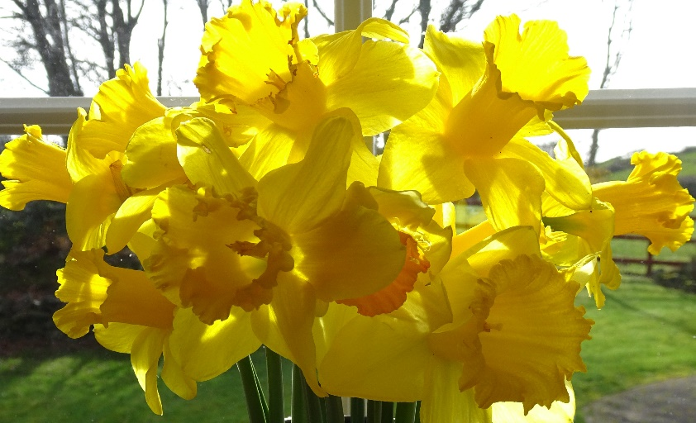

A Little Gold Goes a Long Way Lynda Tavakoli

The Crozier Stage

Their fiddleheads hide
tiny leaflets,
waiting to unfold

and flatten outward,
in a range of greens.
Ferns may have no flowers

but their furling
like a tiny, curled fist
or the long snout of a seahorse,

brings rumour
of awakening.
Slowed down over hours

with a canon digital,
when the slow reveal begins
it’s as though the plant

is looking around at spring,
moving with the grace
of a ballet dancer.

Gerard Walsh

Phenology*
Spring moves up the country at walking pace
alighting on the shingle beaches of the Channel coast
strolling country lanes and crossing fields

bringing budbreak and leafburst
igniting orchard blossom. Copper speckles poplars,
and northern hardwood forests fill

with birdsong and hazy green.
From south to north each sign of Spring
takes three whole weeks to navigate the country.

As the temperature lifts another sweltering degree
the plants leap five days sooner into leaf
and Spring has upped her pace now, walking faster

her breath is the Sahara, chasing
migrant birds before her. She’s picking up
her skirts these days; she begins to run.

Judi Sutherland
* The study of periodic events in biological life cycles and how these are influenced by seasonal and interannual variations in climate, as well as habitat factors

Oakwood’s Ethan*

for Lee

(1966 - 1991)

I did not know the world at that moment
only the rain came as if the world
knew me kneeling
where he lay

His mares gathered
each beauty a prayer
“To the earth
To the sky
To returning ghosts of springtime.
Give this dear one peace.
He was a little crazy
but he was a good bay.”

PD Lyons

*Was a dark chestnut Morgan horse registered with the American Morgan Horse Association (AMHA) as #16783

Spring

Snowdrops glowing like jellyfish
in the wild grass of the bottom field,
the top field—
puncturing the road ditch
opposite our cottage.

Feral, cold-clinging,
orphaned beauty ascending out of
bulbs someone had thrown away
sometime
no one could remember—

from the graveyard of the unwanted
they did the only thing
they knew how to do.
They grew.

Giulia NíChonmara

Uprising

Beneath the machair on Omey Island
a colony of primrose surging towards the light

Sands shifting over cockles in the midden
a human skull watching from the warren

Whipping wind scattering the foreshore
a tooth lodged in the shell-rich plain

Skies opening for a wasted corncrake
a mandible floating in milk green sop

A famine village sacked by staghorn beetles
three hundred femurs breach the burial ground

An army of bones on the Hill of Women
little raven surveils the blasted domain

An absent doe draws a rising scream
venerated, forgotten, risen again

Spring is no gentle thing

Annie Egan

Ushers

I swallow slivers of morning light
spindly beams streaking through curtain cracks
my eyes heavy half open

bare birch trees outside
a stirring two-note tune delivered
teach-er teach-er teach-er teach-er
I lean to these tiny feathered messengers
white cheeked yellow vested in black ties
giddied by the lengthening day
their good news dispatched to others
poised on nearby wires almost hysterical
they join in joyous release
unstoppable
carrying life forward

I lift my face to a hesitant sky
let spring’s ushers take hold

Anne Donnellan

Bridget and the Bananas
- fantasia at Imbolc –

Fadó fadó, a boat crewed by daoine gorma
was beached san oirthear, after a storm
which ripped its sail and shattered its rudder.
The men were an oddity to the ruddy faced locals
who thought their curragh enormous,
like a meeting house on water, with fire on board.
It was not recorded in the annals
how they got to Cill Dara along the Esker Riada
with tackle and gear salvaged from their wreckage;
but a storyteller got wind of the amazed pleasure
which overwhelmed the Abbess
when one of the sisters arrived in the refectory
bearing a gift from ‘strange, dark-skinned people’:
a food-basket with a rack of sickle moons,
like skin to the touch, yellowy-soft, a sun-filled sweetness.
The visitors were amazed at the reception of their gift.
‘Banan’, they said, pointing to the basket,
‘méara móra’, adúirt sí, and divided them among the company.
As the sisters chanted buíochas, the sailors added their music
with reed pipe and goatskin drum, hosts and guests as one,
a taste of heaven which put them all faoí dríocht.
And the daoine gorma departed whence they had come.
‘What was it we ate last night?’ ‘Bananaí,’ she said.
And that name has stayed with us to this day.

Philip Quirke

Petals
Our faces were reflected
on the window as we stared out
through rain darkening the grey
pavements and as we stared a slug
slid up against the flow on the glass
and as a snail swirled its secret script
the pressure of the darkness
drove us out of the house
to the slimy path and the woods
where the wren blasted its song up
into the rain and robins and blackbirds
sang at the tops of the budding bushes
and as we walked under a cherry tree
we followed a bubbling spring
where two petals swirled on
the surface from puddle to puddle
and the brightening sky lit up
the streams the petals skimmed
across and we followed them
on paths that had been hidden to
us our whole lives and then we
reached a beach we'd never seen
and threw pebbles and sticks
out into the glittering sea
Paul Bavister

February, early

Each star shuffles back to bed,
darkling and drabbish.
Come morning, windows

arthritic with rain
are swollen with night-stories;
but watch, these widows

become young again,
hair in rollers, dream-sewing
a new dress for spring:

they hum as they work,
hand-stitched indigo hems, each
thread bright as bird song –

Olga Dermott-Bond

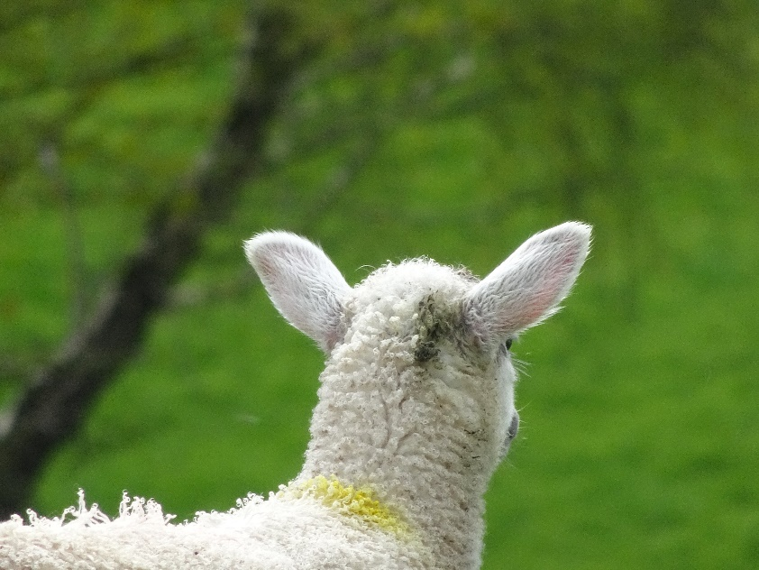

First Reflections Lynda Tavakoli

“My” Tree

“Everybody should own a tree this time of year. . .
in the way that one comes to own a tree by seeing it
at the turn of the road, or down the street, or in a park,
and watching it day after day, and seeing color come
to the leaves. That way it is your tree whenever you
choose to pass that way. . .. And it will be yours as long
as you can remember.”
– Hal Borland, Sundial of the Seasons

She lives three blocks away from here. Let me
introduce you. If you say it slowly, her name
is also a poem. Populus deltoides Bartram ex
Marsh subspecies monilifera (Aiton) Eckenwalder.

She “contains multitudes,” as old Walt Whitman
would say—of science, and other people’s lives,
all men, as it happens, who “discovered” her
along plains and hills and streams and rivers,
and even climbing mountainsides. Though those
who first knew her called her Ti’is, Wagachun
Waga cha, Paako, Natakaaru, Mda zho.” Alamo.

I call her Lightning Woman, for she has survived,
as we women often do, a strike near the heart
that nearly killed her: the loss of love, a child,
some great thing in our lives that strips us of
our skin, leaves us open to Winter, to Nature
feasting on us. That’s the way. It’s a myth to say
that a tree “heals” from such a wound. Look
closely. She’s left bare the long spiral patch
that runs like an open field across which her
life is written. She’s curled the edge of bark
an expert magician of wood, and sent life
elsewhere, seeking light with limbs as open
as arms, Spring after Spring, sharing herself
with the sky, catching the drift of pollen.
from her fellows, seeding the air with her
labors. She’s an old woman, to have been
left here, flourishing above an ancient
gravel pit carved into a park. The coin
of her leafy realm, for she is queen of
all the nearby species, is green, is gold.

Even in winter, leafless, you can read
her story in the calligraphy of branches,
sorrow and joy etching themselves into
her star-studded biography. She curves
just there, at the sky-strike, graceful
in a life of restoration, of reach and reach
and reach. . .

Kathleen Cain

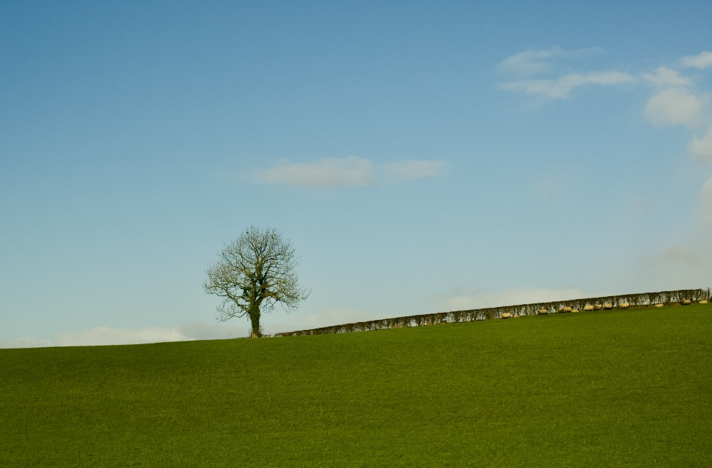

A Winter Tree Toward Spring Ignatius Lally

On a Sunday Morning

Waking you up in slow-mo,
sleeping in out of the snow.

You, a long time coming,
peel me like a clementine,

the heat of you within kicked in.
I melted in you those months ago.

I keep your morning breath in mine –
hold it, thaw the frosts through time.

Paudrig Lee

Bearing Witness

In spite of it all, willow warbler and chiff chaff
are back from the warm south,
blackcap song flows through oak and willow,
the starling makes a star overhead
beak full of straw for the nest box
and when I step outside in late dusk
I smell sweetness, a garden at full pelt.
Cuckoo calls keep pace with cuckoo flowers
scattered across the neighbour’s field,
purpling verges up the road.
Birch and rowan have put on their best green,
fresh leaves sucking in sunlight,
blue tits ferry caterpillar cargoes to their young,
house martins rebuild at the gable.
In the pond fat tadpoles shoal
while newts rise to sip the air,
agitate the water’s skin,
make its light dip and glitter,
speckled bellies flashing as they turn.
Water boatmen row upside down,
water skaters skitter over surface tension.
And humans? We have our own tension,
bearing witness to our beautiful messed-up world.

Nicki Griffin

Release

From my classroom window
I watch this single leaf’s spasm
as it struggles to free itself
from cobwebs hung along a sill.

Tiny torso, moving back
and forth, back and forth
like a trapeze artist about
to take flight, remembering
she has done this before
she can go, leave, relent, recalling
what comes from release: air, space,
a ferrying breeze, room to breathe –

I want to reach through this pane
and brush the sticky entrails away.

Mollie Berry

Foothold

Nests of brittle twig, mottled feathers,
erupt with little chicks,
anxious in their bone cages
disrupting the gentle waves
pounding frequencies of terror
as you both step on stone edges
licked by the Atlantic
searching the abyss for treats

Amanda Shannon

The Clouds I Recall

As a child, my favourite thing to do
was lie in the grass and tell stories with the clouds.
That was the only safe space I knew then.
Hidden by grass and saved by the sunshine.
By the time I was a teen,
I had stopped trying to tell their stories altogether
no one seemed to believe them when I did.
The clouds felt heavy
and there was nothing of value they had to teach me anymore.
In my twenties, I ignored the clouds completely
unless stoned, I tried to count them
but forgot which way was up or down!
My thirties arrived with a flutter;
clouds were the least of my worries.
Busy pretending to be someone
who fits into a place or time.
So, when I turned forty
I forgot how to be mad at them
and lay down in a field once again.
The clouds were exactly where I’d left them
and their stories greeted me like an old friend.

Rachel Roberts

My Year with the Hare

In February, I arrive, new to this place, and she spies from the scant yellow gorse.
Or she sits in the lane, high on her heels — and I slow my step and pause.

In March, the golden bloom spreads and warms the view.
Spring is in her ear, twitch, twitching it anew.

At April’s end, I come again, and while she’s nesting in her form,
surprised by heat and clear blue skies, I joy in being warm.

I leave once more, and May unfolds in long days of fiery glow.
She flits through ferns, and grasses green — pit-pats soft and low.

By June, she travels in corridors, carved by her own passage,
her ears aloft — her young concealed —wary of trespassers.

On our return, she lifts her paw — July’s heat and voices thrumming —
she tilts her head, the air’s alive with scent and insects humming.

In August — free — her young are strewn, but more intruders come along.
Shattered calm, she stays away, her instincts true and strong.

In September’s rest the land is hers, and, emerging, not arriving,
she stands steady on the edge of days — shortening, dimming, surviving.

Through October’s damp and misty hours, she zigzags silver dew.
Her hardy back, dun and slick, bares Autumn’s washed-out hue.

In November, dark furze spikes through briars and withered berries,
and she climbs the ridge and sniffs the air for all the cold wind carries.

December flows through muddy lanes, and trickles on to where
her frosty trail runs lone and slight, in moonlight bleak and bare.

From January’s storms and gales, she hides, and I yearn for signs,
of the clock to tick to lighter days — and her return in lighter times.

In my fixed gaze, the wild wind waits, and gentle whispers blur,
and then at last the circle turns, and life begins to stir.

At break of day, she knows me now, and no longer stilled by fear,
she ventures forth — sure-footed, strong — and claims the newborn year.

Sandra van Beurden-Hopkins

Incantation

May neither wealth nor sadness overwhelm you,
may sunshine follow in your tread,
may bitter winds not chide you
nor poverty’s chill find grip.

May dreams not leave you empty,
nor shadow you with regret,
may music echo your weary step
down every crooked path.

May joy and light embrace you
like a blue scarf wrapped around
and may you find redemption
In the everyday, wherever it may lead.

Kevin Dowling

Crimson

my first memory is red
a dress my mother wore
as she kissed me good night
in crimson twilight

red tulips danced in our garden
that spring, swaying
on spindly stems in the breeze
I danced, too,
for the mindless joy
a child has
when the world is new

the world is old now
I have seen too much
still, I take joy when I can
singular moments in the evening
when the light slants just so,
I dance in crimson twilight

Joanne Draper

The Little Fires of Brigid Poetry Competition Winners 2026

Overall Winning Poem – What Name Shall We Give The Baby by Nollaig Rowan

Joint Runners-Up

So, tell me by Maria Hoey

&

Bonfire by Stephen Brock

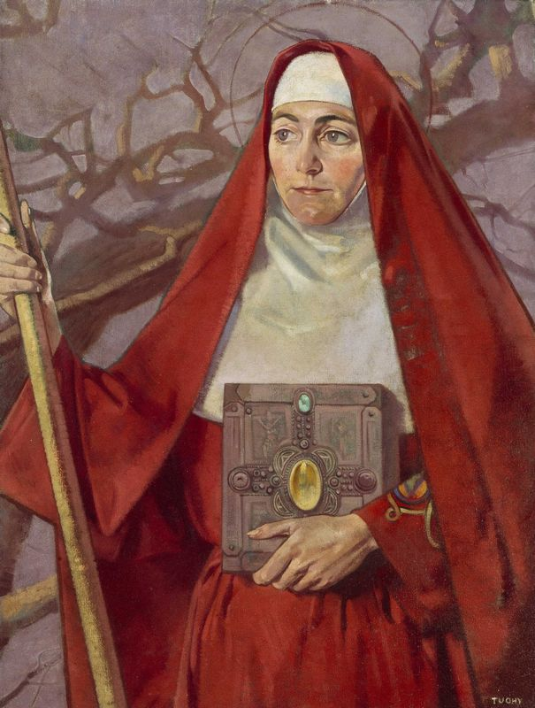

Saint Brigid by Patrick Joseph Tuohy (1894 – 1930) Oil on canvas

What Name Shall We Give The Baby

I was told that a wise woman from the East
Travelled from Duibhlinn to found an oak church
In a place full of birds she called Cill Dara.

In my world the Abbesses made the rules
Lording over Abbots in that matriarchal
Family in the eighth century.

I made the long journey from bloated belly
Down the birth canal to be born in February
To my Abbess mother Aifric and her holy sisters.

I was baptised with fire stoked in the plains of Cill Dara
A cloak wrapped round me for warmth in winter
My eyes held the knowledge of centuries.

Abbots looked on, helpless, but promised
Their assistance in manly tasks of wood-chopping
Deer-slaying, moon-watching and protection.

Meanwhile I grew, nameless so far
Winter robins and wise women gathered
‘We must give the child a name, a dedication’.

I squirmed in my woven wool, itchy and irritated
Do they not remember the wise woman from the East?
‘Brrr, brrree’ I mumbled from my swaddling.

‘Bríd’ one said ‘Bridgie’ said another
‘Breege’ said a third, not daring to shout
The sacred name of their founder.

When Abbess Aifric spoke she was calm
And inspired ‘My baby is Bríd-óg
Like our saint and her spideog.’

Hail Brigid, goddess of fire
Of healing, of water
And of women doing their own thing.

Nollaig Rowan

So, tell me

So, tell me,
which was it,
Brigid, Bríde, Brigantia?
Even your name is a mystery.

And who and what were you,
Saint?
Goddess?
Christian?
Pagan?
Or did you have one foot in the past
the other in the now,
as a wise woman would know how?
They claim you as their patron, you know.
all sorts,
poets and brewers,
scholars and midwives
sailors and cows.
A rum mix if you ask me.
And I have to admit
that I find it hard to pin you down,
you turner of water into beer -
I like that by the way -
the common touch
cooler than the whole wine thing…
But I like to think that you were all woman,
flesh and blood
brazen and bold,
no man would take your name from you
or anything else you did not choose to give.
And I’ll think of you,
on this day of Brigid
this Imbolc
this space between the darkness and the light
where, whoever and whatever you were,
you still shine bright.

Maria Hoey

Bonfire

“It was a pleasure to burn”
- Farenheit 451, Ray Bradbury

Beneath, below
Toiling on barren soil, the garden of my heart
I search for kindling down every avenue, each life I cycle through
And dole them out to the flames
Devour my shame, my grace; feed me your words in return
Burn bright, little bonfire, burn

Great flames lick skyward like a pack of ravenous dogs
You are my will and testament, my hungry God
A thrall to your beck and call, whore for your scorched breath on my neck
Without a care for what’s next or what came before
At no alter do my knees fold save yours
We dance madly in the garden, naked and aching, night after night
Crackling flames my lullaby; a fireside serenade
All your secret teachings I long to tease and unearth
Burn bright, little bonfire, burn

Make me your blue-eyed pagan; I’ll sing your sermon in this singed tongue
Til my throat stings and my lungs combust
Til I’m ashen faced, lamed by age, til all the nails in my coffin rust
I’m breathing smoke, savouring the taste of soot
Sure the heat hurts but God, I adore your touch
Set me alight, make a pyre of my heart
Burn bright, little bonfire, burn

The garden is stark, charred, cracked open wide
It bears no fruit save the inferno I have nurtured like a child
I am beneath, below. I am so far below. So
come, devour me whole, eat me fast, eat me slow, bite, chew, swallow
Make me yours in black baptism; wedded to the light. Make me an ember,
colour of twilight, sailing through the night like a blazing party favour
I want to live in the glow of your holy locus
I’ll starve to keep you full, so the spark may survive
Burn bright, little bonfire, burn
Fucking burn me alive

Stephen Brock

Notes on Contributors

Rosie Aziz is an emerging English-Kurdish poet from Manchester and an alumna of the University of Manchester’s Centre for New Writing. Having appeared in Drawn to the Light Press, Lighthouse, and Obsessed with Pipework, her poetry fuses her love of lore, mythology and fairy tales with honest, everyday reflections.
Paul Bavister has published three poetry books, the latest being The Prawn Season (Two Rivers Press). His recent work has appeared in Glass, Porridge, and Ink, Sweat and Tears. His poem, Starlings came highly commended in the RSPB/Rialto poetry competition.
Mollie Berry writes and teaches literature in London.
Faye Boland won the Poet's Shout Poetry Slam 2025, the Robert Leslie Boland Prize 2018, the Hanna Greally International Literary Award 2017. She placed third in the Bere Island Poetry Competition 2024. She was highly commended in the Fool for Poetry Chapbook Competition 2024 and the Desmond O' Grady Competition 2019. Her collection Peripheral was published in September 2018 by The Manuscript Publisher.
Chelsea Bright is a writer and editor from county Westmeath. She founded Sparks Literary Journal in 2023. Her poetry has been featured in The Poetry’s Dead Anthology vol 2, Swim Press and The Martello Journal. Her poetry explores the things that many of us leave unsaid, even to ourselves.
Stephen Brock is a North Dublin based writer and poet. He has previously been published in the Martello Journal and the Stoney Writers’ Collection.
Kathleen Cain is a poet and nonfiction writer from Colorado. Her poems have appeared in The Comstock Review, Abandoned Mine, Bristlecone and many other literary magazines and anthologies. Nature is her religion, poetry her liturgy. https://www.kathleencainwriter.com
Finn Cassidy (he/him/his) is an Irish poet, living in the French-Alps. His poems have featured in a variety of international poetry journals and anthologies. He is currently completing his first full poetry collection: Notions of Starkology-Codology. For all things poetry-related, you can contact Finn at fcassidy@email.com
and on X @FinianCassidy.

Patrick Deeley is a poet, memoirist and children’s writer from Loughrea. His tenth collection, Keepsake, was published by Dedalus Press in 2024. His awards include the Eilis Dillon Children’s Book of the Year Award, The Dermot Healy Poetry Prize, and The Lawrence O’Shaughnessy Poetry Award.
Olga Dermott-Bond is from Northern Ireland and lives in Warwickshire. She has published two pamphlets: apple, fallen and A sky full of strange specimens. Her first collection Frieze is published by Nine Arches Press. Her poetry has been featured in The Guardian, and she won the Strokestown International Poetry Competition 2025.
Teresa O’Connor Diskin’s work has been published nationally and internationally, including, among other publications: The Galway Literary Review, Skylight 47, Reach Poetry, Drawn to the Light Press, Lothlorien Poetry Journal, Magpie, and she was shortlisted for Poems for Patience 2019 and 2022, and New Irish Writing 2025.

Anne Donnellan has published two collections of poetry with Revival Press Limerick. Her second collection If Only We Could Bottle It was published in December 2025. Anne’s work has appeared in several poetry journals including Crannog, Skylight 47 and Ink Sweat and Tears. She curates and hosts the Poetry Lobby Galway.

Darren Donohue’s work is published in Poetry Ireland Review, Banshee, Cyphers, Irish Times, Sunday Independent, Strokestown Poetry Anthology, Dedalus Press, Honest Ulsterman, RTE Culture website and Books Ireland. He received the Dennis O’Driscoll Literary Award, 2020. His debut poetry collection titled, Secret Poets is published by Turas Press.
Kevin Dowling lives and works in County Kilkenny. Member of Clogh writing group in North Kilkenny. Has been writing mainly poems and stories for a few years. Poems published in The Kilkenny Anthology, Kilkenny Poetry Broadsheet, Stony Thursday Book, Where I Am, Riposte. Poems also included in Kilkenny poetry phone line.
Joanne Draper is a poet and writing instructor for a small community college in southern Idaho, USA, as well as for Amherst Writers and Artists. Her most recent publication was in Silo Literary and Visual Arts Journal.
Tim Dwyer was raised in Brooklyn by Irish immigrant parents, and now lives in Bangor, Northern Ireland. His debut full collection, Accepting The Call (templarpoetry.com), has won the Straid Collection Award. His poetry appears regularly in Irish, UK and international journals and previously in Drawn To The Light.
Annie Egan lives by the sea in Galway, Ireland with her partner, three daughters and too many pets. She works as a human rights researcher. She has recently been published in Abridged, Crannóg, Culture Matters, Drawn to the Light, Poets Republic, The Bangor Literary Journal, The Belfast Review and The Madrigal.
Orla Fay is the editor of Drawn to the Light Press. Her debut poetry collection Word Skin was published by Salmon Poetry in 2023.
Nicki Griffin lives in Mountshannon, East Clare. She has two collections published by Salmon Poetry: Unbelonging, 2013 and Crossing Places, 2017. A third collection, the Dark & the Light, is forthcoming. She has been published in a wide variety of anthologies and journals. She hosts a monthly poetry evening in East Clare.
Maria Hoey has been writing since she was eight-years-old. Her poetry and articles have been widely published and her short story, Reading Brother Boniface, was shortlisted for the Michael McLaverty Short Story Award. Her debut novel, THE LAST LOST GIRL, was published in July 2016 and has gone on to be shortlisted for the Kate O’Brien Debut Award 2018 and the Annie McHale Debut Award 2018. Her second novel, ON BONE BRIDGE, was published in July. BAD SWEET THINGS was published in Kindle e-book in September 2021.
Maria lives has one daughter, Rebecca, and lives in Portmarnock, Co Dublin with her husband, Garrett and their moustached cat, Midge.
Ignatius Lally is a playwright & photographer living in Fermanagh, where the picture was taken. He has written plays for BBC Radios 4 & 3, had two plays at the Edinburgh Festival and was writer in residence at Solent People’s Theatre. The picture was taken on 2nd January.

Paudrig Lee is a poet from Killeagh village in East Cork. Smoking Bees, his debut chapbook, reflects his interests as a local historian and photographer, with striking observations of the natural world, historical injustices, and family dynamics shaping the collection. His second chapbook, Chance Meeting, will be published this spring.
PD Lyons born and raised in the USA. Since 1998 has resided in Ireland. Lyons received Mattatuck College Award for Outstanding Achievement in Poetry, Bachelor of Science with honours from Teikyo Post University. The work of PD Lyons has appeared in many formats throughout the world.
Martina Madden works in the heritage sector and is inspired by her creative surroundings, people and a sense of place. Martina had work published in 2025 in a number of literary journals including Ragaire Literary Magazine Issue 3, The Stony Thursday Book Issue 50 and pending in the Quillkeepers Press.
Giulia NíChonmara (Julia McNamara) is a poet from Cork whose work explores womanhood, identity, and intergenerational trauma. She holds an MA from the University of Limerick and was shortlisted last year in Ó Bhéal's 12th Five Words International Poetry Competition.

Philip Quirke had Journey to the Shore published by Lapwing (2008). Two self-published followed: Bruised Reeds (2015) and Taking Stock (2024). Continues to write. Regularly submits poems and prayers to HookofFaith, website of Diocese of Ferns. Lives in Wexford town, sharing life with Margaret (Galvin) and their son Ibar.

Rachel Roberts is an emerging writer based in Carlow, whose work is informed by a rich background in theology, philosophy, yoga, and creative writing. Her first short story, ‘The Hand in the Grave’, was published in The Shadow of the Steeple when she was eleven. Other short stories are featured in the anthologies Original Sins and By the Light of the Moon.

Her essay ‘When all is not lost’ is featured in the online publication The Green Diary. She has prose poetry featured in Niamh Cunningham’s socio-eco art practice, ‘The Memory Palace of Trees’. In 2013, she won the Carlow Literary Award and was a runner-up in 2014. She is also a winner of the 2022 Power of Words short story competition and is featured in their anthology Locked In.

Her most recent publications were the selected poems ‘Rituals’ & ‘Jealous Boots’ featured in The Banyan Review Autumn Edition ‘23. In September 2023, she received funding from both the Arts Council of Ireland and Carlow County Council to host a Culture Night event, ‘The Koan of Yin & Storytelling’. She is currently working on her first poetry collection.

Nollaig Rowan, poet and short fiction writer has had work published in Incubator, Skylight 47, Boyne Berries, From the Well, Angle and other journals. She's regularly featured on RTE radio 1 Sunday Miscellany. One of her poems was selected in this year's poems for patience competition. Nollaig divides her time between Dublin and Sherkin Island, West Cork.

Amanda Shannon is a poet and performing artist based in County Clare. Her poetry has appeared on Eat the Storms, in the In the Air anthology, and on Clare FM. She serves on the Steering Committee of the Clare Poetry Collective and is currently developing her first poetry collection.

Judi Sutherland is an English writer currently living in Malahide, North County Dublin. She has published two pamphlets, The Ship Owner's House (Vane Women Press 2018) and Following Teisa (The Book Mill, 2021).

Lynda Tavakoli lives in Baillies Mills, County Down. She is a professional member of The Irish Writers Centre and has been nominated for the Pushcart Prize and Best of the Net Awards. Her poetry, prose and photography have been widely published in numerous anthologies both at home and abroad.

Sandra van Beurden-Hopkins is a British and Irish poet living between Ireland and the Netherlands. Her work is rooted in memory, landscape, and family history, with particular attention to rural life, migration, and return. She writes from lived experience and close attention to place.
Gerard Walsh is from Co. Kildare. His poems have been published in Writers Forum, Drawn to the Light Press, Apricot Press, Skylight 47, New Isles Press, Anomaly Poetry, Longford Poetry Anthology and he was runner-up in Trim Poetry Competition 2022. He is a part-time library assistant.

Simon Willson is a musician and emerging poet with a PhD in composition from Aberdeen University. After experiencing significant hearing loss, he now focuses on poetry and is developing his debut collection.

Drawn to the Light Press
Spring 2026

Faye Boland Patrick Deeley
Martina Madden Simon Willson
Tim Dwyer Chelsea Bright
Finn Cassidy Darren Donohue
Teresa O’Connor Diskin
Gerard Walsh Judi Sutherland
PD Lyons Giulia NíChonmara
Annie Egan Anne Donnellan
Philip Quirke Paul Bavister
Olga Dermontt-Bond Lynda Tavakoli
Joanne Draper Rosie Aziz
Kathleen Cain Paudrig Lee
Nicki Griffin Mollie Berry
Amanda Shannon
Rachel Roberts
Sandra van Beurden-Hopkins
Kevin Dowling Ignatius Lally

& the winners of The Little Fires of Brigid Competition

€20
ISSN 2737-7768



