Drawn to the Light Press

Issue 9

June 2023

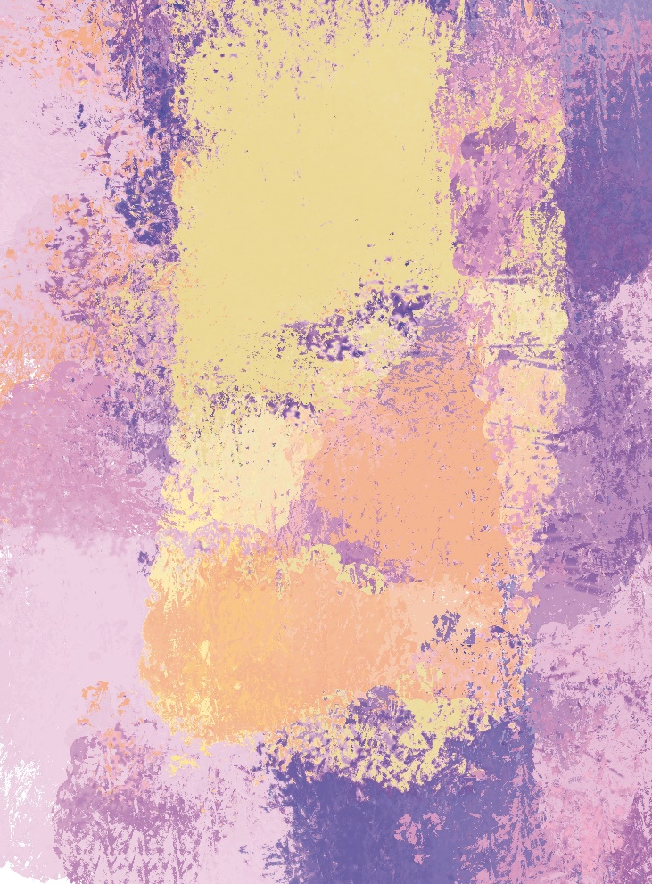

A Storm Almost Stilled Edward Lee
Editor: Orla Fay

Published by Drawn to the Light Press

ISSN 2737-7768

Next issue: October 2023

https://drawntothelightpress.com

Twitter: @DrawnPress

Instagram: @drawntothelightpress

Facebook: @drawnpress22

Patrons: Anthony Wade
Arthur Broomfield
Attracta Fahy
James Finnegan

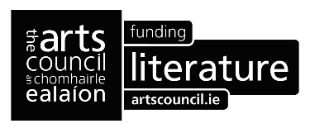

Drawn to the Light Press is edited, designed, and produced by Orla Fay.

Cover design A Storm Almost Stilled by Edward Lee

The works included in this issue are copyright of the poets and artists ©2023 and may not be reproduced or changed in any way without the permission of the individual author.

Drawn to the Light Press is ©2023 of the editor. All rights reserved.

Contents
Ruby (Beautiful) | Clare Fagan | 6
Beyond Rubies | Anthony Wade | 7
Making love to empty dreams | Sven Kretzschmar | 8
Gorta agus Grá | Craig Shalvey | 9
A Love Note | Melanie McDowell | 10
Effet de Neige | Breda Joyce | 11
And we are older now | Alison McCrossan | 12
A Gentle Want | Edward Lee | 14
The Human Condition | Wendy Webb | 15
In a Harbour | Kris Spencer | 16
The Salad Boat – gathering leaks from the sky | Noel King | 17
The White Hart of Bootle | Ciarán Hodgers | 18
Legends of Pop | Michael Durack | 19
Bench Warmer | RC deWinter | 20
Memory of Clay | Gerard Walsh | 21
The Exact Sum | Arthur Broomfield | 22
Dry | Gail Sheridan | 23
Misfit | Gail Sheridan | 24
Feather Flower: After, Is The Beginning | Mandy Beattie | 25
A Reluctant Road | Maeve Heneghan | 26
Planting | Patricia Anne Moore | 27
Anglesboro | Bernie Crawford | 28
Il Dottore | Maeve Keane | 29
At Oldcastle, Co. Meath | Máire Morrissey Cummins | 30
Echoes | Eamon Cooke | 31
I Carry with Me | Deirdre McKernan Crosby | 32
Ballycroy Birdbox | Anne Donnellan | 33
Empty Nest | Attracta Fahy | 34
A nesting bird being fed | Breda Joyce | 35
Goldfinch | Breda Joyce | 36
Bus Number 8 | Catherine Ronan | 37
Night Bus | Brian Kirk | 38
Fluture | Anamaria Julia Dragomir | 39
Butterfly | Anamaria Julia Dragomir | 39
Mayfly | Teresa O’Connor Diskin | 40
The Embalmer | Alice Doyle | 42
Bedrock | Frank William Finney | 43
Kodachrome | Karin Molde | 44
On reading Olav Hauge, I realise I never wanted the whole truth – only, just a hint | Fergus Hogan | 45
Moonlight | Kenneth Hickey | 47
Night-time in November | Vinny Glynn-Steed | 48
Gathering the Approaching Times | Edward Lee | 49
Notes on Contributors |  | 50

Editorial

The solstice is upon us, and we are ephemeral as the insects in Tersesa O’Connor Diskin’s Mayfly:

Outstretched wings and legs
Just for one day

Yet, we have days stretching out before us, ere Night-time in November where Vinny Glynn-Steed writes

that in a field a forty-gallon cast iron pot sits,
as a relic to colder times…

Edward Lee paints us as A Storm Almost Stilled while we are Gathering the Approaching Times. Everything is fleeting, beauty, love, grief, relationships, and nature. Fergus Hogan explains,

truth is the last fire from winter’s windfallen sticks
truth is a piece of yesterday’s story that has died

And Breda Joyce sings,

So easily fooled by untainted snow;
what lies beneath we cannot know.

Orla Fay 21/06/2023
Ruby (Beautiful)

She takes the nicest pictures,
She captures herself in a beautiful light,
She captured me in a different light,
Or at least she tried to.

She is beautiful to look at,
She is poetic material.
I never had the urge to write about nature until I met her,
For I met her under a red light,
And ironically,
She’s a beautiful Latin phrase for the word ‘red’.

However,
Now I just feel ungrateful,
Because she is not a burning flame,
She is not the shade of red that I want.

Clare Fagan

Beyond Rubies

Aching impotence,
my lover lying ill,
balancing painful awake
and restless asleep,
choking frustration,
unable to offer alleviation,
effect any release,
merely a soft word,
a caress of tangled hair,
a drying of sweated skin,
smoothing a creased pillow,
a tidy of crumpled bedsheet,
small statements of love,
declarations of devotion,
the most precious and enduring
when all else fails,
when nothing else remains.

Anthony Wade

Making love to empty dreams

There you stood in the door of thirty-three years
presenting me with an expensive bottle,
unaware of me not drinking red.
My poetry fled my bones on the porch

supplied with brown beers and crisps
and us sitting, inhaling the garden
and a blackbird’s canto.
Watching clouds die away into skyfire,

undeniably aware of your nearness
and the table separating us. After
watering crops we went inside,
not quite bridging the space between us

while vegetables simmered on the stove.
The distance grew over dinner at a bigger table,
left me wondering: was it merely physical?
Was that the evening I did not fall for you?

Sven Kretzschmar

Gorta agus Grá

Loving him was
an involuntary fast.
He fed me crumbs
and I called it
nourishment.
Leaving me
empty as a promise
and hollow as his word.

Now,
I can hear what my
grandmother
would say about
men like him;
Sure wouldn’t he happily
get fat
and leave you
with nothing but
rotten potatoes?

Craig Shalvey

A Love Note

If it weren't for you
I'd drink
Chablis
for breakfast
at 14:45 and
live in a hovel
with nothing to eat
but packets of crisps and
tins and tins of anchovies.
The children wouldn't go to bed
or brush their teeth
or even go to school
at all.
Oh, and I'd forget
little matters like
passports, meals, the roof,
bank accounts, insurance,
cars and bills.
Yes, quite fortunate really
come to think of it
that you married
me at all.

Melanie McDowell

Effet de Neige
after Monet’s The Magpie

The beauty of cobwebs on an icy day
belies the dust we thought to wipe away.
So easily fooled by untainted snow;
what lies beneath we cannot know.

A magpie’s eyes glint starkly
from his perch, he patiently awaits
the one who dares shadow
his pristine patch.

Breda Joyce

And we are older now

Following you from meadow to river,
I thought these days would never end.

Whatever the weather, more often clots
of clouds and incessant rain, we'd be here, me learning

the ways of rabbits and fox, the mystery of fish.
I pulled away from your embrace and swam, just swam,

like there was nothing else I might do. You were caught off guard by my speed, in seconds out of my depth.

We drifted apart, my doing, my youth, my queer desire.
I travelled across the sea to the city, forgot

but never forgot where I came from, the call of taunts,
the shame in my head that made my knees shake

when I walked through my home streets. I’d return
for a weekend, spend it alone on our stomping ground,

wondering should I stay. And back in the city, the thrum of thousands of feet, buses, underground trains

staled.
How hard it was to settle back in upon the inevitable.

How we’d have a coffee and walk the fields,
your steps faltering. Then the walking stick.

Then the frame. Then hospital, rounds of UTIs
that shook you, body and mind.

How you came around bright but without
the use of your legs. How now I wheel you

to the garden and we name beech and oak and sycamore in woods at the back, study the valley of the Lee,

the meadows and hills. How you are willing
to be here with me until your time comes at last.

Your big hands veined
and knotted from hard work, oh, the hard work of it all.

Alison McCrossan

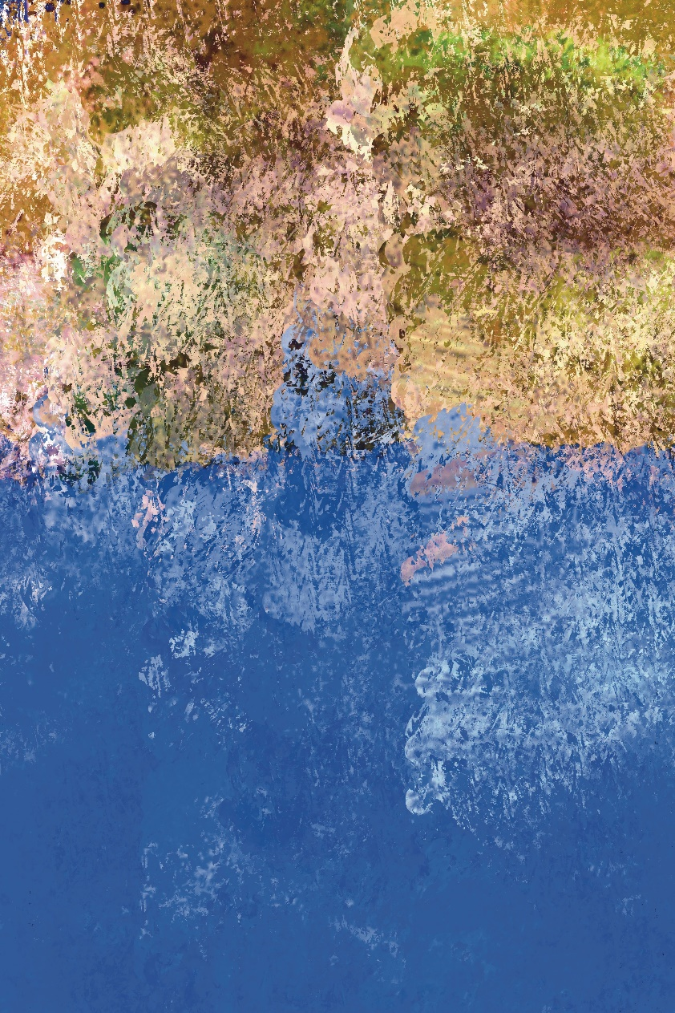
A Gentle Want Edward Lee
The Human Condition

To have eluded death breathed at the last
in manmade years, I have seen every stage.
Dying’s human condition – into past,
there’s never calm acceptance; simply rage.

In manmade years, I have seen every stage;
not the final moments, just the fallout.
There’s never calm acceptance, simply rage/
disbelief/despair/too early callout.

Not the final moments, just the fallout
of family: dreams, hopes and future ways.
Disbelief, despair, too early callout,
despite infirmity/age/health/lost days.

Of family dreams, hopes and future ways,
dying’s human condition - into past.
Despite infirmity, age, health, lost days;
to have eluded death breathed at the last…

Wendy Webb

In a Harbour

That poignant abolition of time
—Jean Cocteau, Past/Tense

This morning, the sky
is washed clean. We drag about
our shadows taking on the warmth

of the coast, same as crickets
in the dunes. Life becomes
a costume. Beauty, it turns out, simply

an accident. And art—an object difficult
to pick up. Here the sunlight hangs
in the air, like pollen. The water in the bay

is so clear the yacht seems suspended
in midair. The purple sail reflects
on the waves, like blood on water.

The boat is moored safe, shallow
in the low tide. And love and time come
towards us without any hurry, and stay.

Kris Spencer

The Salad Boat – gathering leaks from the sky

Big blue Kraft Mayonnaise buckets
placed strategically collect rainwater
in the echoing yard behind the pub.
In a random row they sit brimming
before the publican goes with his measure
and says, I have three inches today.

His wife having left,
sunshine hits, slips high
enough for a brief hour
to glisten in the water buckets
and a red door closes the yard
leading to the treasure trove awaiting the publican.

Noel King

The White Hart of Bootle

Majestic amidst the terraced-dust,
he lit up the red brick and mossy roof tiles.
Eyes fixed, like a visitation,
towards the little myth pacing past my window.
Suddenly, this small world felt big again,
as if wonder could still exist,
as if it could still surprise me,
as if the calluses of a cynical heart
could just pop off.

When they shot him,
it was a reply to whatever message he had for us,
calling from another world,
that shrinking place in our hearts
where we allow ourselves.

His blood pooled in the concrete,
poured past the hazard tape,
escaping the confines of their dirty work.

I don’t believe them
when they tell me
there’s nothing to see here,
move along please.

I watch a desperate breath, the last of his heat,
escape and dissipate into the cold Mersey morning.
The traffic flows on, the streets return
to their dulled and ordinary colours.

Ciarán Hodgers

Legends of Pop

Waking from a dream Paul McCartney realised
that a melody had sprung from his head
fully formed like Athena from the skull of Zeus.
The lyrics yet to come, he scrawled an improvised :
Scrambled eggs.
O my baby how I love your legs.
Not as much as I love scrambled eggs.
And that is the origin story of Yesterday, believe it or not.

As easy to believe that Mick Jagger or Keith Richard,
or both, should roll over, half-stoned
to find a refrain simmering in their creative juices.
This rock ‘n’ roll classic would bear the provisional title:
(I can’t sing like) Paul McCartney.

Or that to complete a hat-trick of miracles
Paul Simon would kick off his duvet, humming a tune
that seemed to belong in an archaic hymnal.
Reaching for his notepad he scribbles a tentative
Like a Mid-Western farmer’s daughter
lately come to town.

This morning as I stirred and yawned a poem took shape
inside my head (without the words, of course.)
While I wait for the lyrics to incubate
I contemplate a pro-tem title.
Legends of Pop might do for starters.

Michael Durack

Bench Warmer
Living on the intoxicant of hope requires bravery,
a magnificent gamble – the surrender of disbelief,
a willingness to sacrifice the present for a possibility
that may never materialize.
If life is a banquet, hope is a fast,
the refusal of substance in favor of purification.
This purging of appetite is never easy;
consigning oneself to what is nothing
but the constant of anticipation is a martyrdom
of choice to be weighed daily, measured against
the enticements of the immediately obtainable,
the seduction of the now.
Life becomes a spectator sport –
the vicarious enjoyment of non-participation
in the human condition, leaving one open
to accusations of cowardice;
only those who have glimpsed the vision
of future perfection will understand
as I fast, as I watch, as I wait.

RC deWinter

Memory of Clay

A wheel head turns,
someone models a hare,

life seems bearable,
hands kneading

or pulling up the walls
seem to replace the evil

of not knowing why
things are just erasing.

I help him break loose
a lid from a teapot.

How can a father lose
memory of his daughter?

Gerard Walsh

The Exact Sum

That moment when the moon’s a pyre
and they’re waxed and packed
for a day on the pier,
bikinis and tubs of block,
flowery shorts and flagons,
and the cars won’t start.
And why is the sun so close
at six o’clock,
where the breaking dawn
sings the morning’s last birdsong?

And he knows he’s at the halting hearth
when they sing hallelujahs to the firestorm
and he remembers that the flash and dance
is beyond Alpha to Omega,

he, the helpless corpse
in the lather of his second shroud.

It’s his time, he who knew
the dots and commas before
the burlesque wrote
that blood in the arteries
communes with the cold
of a midnight moon.

Arthur Broomfield

Dry

We preferred to walk in the rain.
I’ll never forget the heat,
the car would be tropical
and you didn’t dare
touch the dial, it was set.
Even the red-faced children
knew to keep quiet.
Oh, he would happily oblige
but you would be paying
for the lift
and mostly in sweat.
Speeding meant he was seething
over one slight
or another.
Slow was passive aggressive,
a laborious shift of the gears -
down to second -
up to third.
The odd reasonable mood
and you got a driving lesson
whether you asked for one or not.
Eggshells shards still stuck
to the soles of my feet.
To this day I question everything,
scan facial expressions for a double meaning,
an expert in body language,
can’t even accept a gift with gratitude.

Gail Sheridan

Misfit
At the online poetry course
they look at me like
I’m supposed to know about it.

Anthropocene, she says,
I haven’t a clue.
I act casual.

She’s a teacher, a few of them are.
Fortunately, they can’t see my hands
I start googling.

The only birds we ever saw were crows,
and what the fuck are rhododendrons anyway?

Gail Sheridan

Feather Flower: After, Is The Beginning

after, Because I Could Not Stop for Death —
Emily Dickinson

We ovened in womb’s-ark
your mollusc the missing of me
but I do not fear you — For how could death
be Wom(b)an? She is afterlife’s rebirth —
I do not get collywobbles meeting what-if’s
in karma’s needles, for I scribbled
in light-calligraphy like an amaryllis
with halo-happenings. I do
not get heebie-jeebies at maps of bones
for I pined for Sky-home’s return
to the mirror of me and our aura’s
aurora-murmuration. I do not fear death
in this masquerade’s disguise and when
the hour comes I will be like Rossetti’s, Venus
Verticordia, reincarnation done — No chains
or ribbons to anchor me to Earth’s plateau
as I wriggle free from this loaned pupa-sack —
Stretch metamorphosis wings in slipstreams
and dance the Seven Sister’s
Seven Veils. No congregation
of rain needed to quench thirst
only You: The Placenta of Me

Mandy Beattie

A Reluctant Road

When you step through the gates of the Old City
don’t be offended, because you stand out.
Aromatic Jasmine tea, sipped by you so often,
will seem like the first taste,
to the passing wide-eyed pedlar.

Or walk in the Summer Palace,
hawkers with cow hide faces, will haggle
with you for cheap tat.
Don’t pretend, the laughing Buddha
who pisses heavenward, never tempted you.
Don’t blame the waiter who kowtows
to your chopstick skills.
He wasn’t to know, a lifetime of noodles
have passed through your hands.

When you recall the Old City,
be happy you lived it once.
Even if that photo of you with the half-hearted smile
under a plum blossom tree,
is the only proof.

Maeve Heneghan

Planting

Such a relief
to be banished to the garden
even now, in winter.

Setting down earlies
and other roots whose names I hadn’t known
celeriac, Jerusalem artichoke,

the trowel broke ground
but my fingers did the planting:

vegetables for the cauldron in the kitchen,
flowers to dress the visitors’ parlour or the altar,
gypsophila a favourite.

Stone walls giving shelter, shifting sky above,
a neglected patch where nothing grew
black soil, the heartening smell of earth.

It was the garden that grew love in me again.

Patricia Anne Moore

Anglesboro

When I was little
I thought it was where angels lived.

My father usually went to work on his motor bike
but on early summer days if he was heading towards
Kilbehenny or Anglesboro he took his push bike.
That bike had three gears, a black tinny cover
over the chain, two sprockets to hold the pump in place.
Metal clips around the ends of his trousers
he wheeled the bike, left foot on the pedal
he swung his right leg over the crossbar and off with him.

And somewhere along a backroad or laneway he stopped,
propped the bike against a ditch or leaned it
along a four-bar gate. And that giant of a man,
in dark overcoat and flat cap, plucked primroses,
purple loosestrife, wild marjoram, and honeysuckle.
He wrapped the stems of his hedge-row bouquet
in long, sweet grasses. And later, insisting that she smells
the wildness, presented it to my mother with the words:

For you, all the way from the place of the angels
at the foot of the Galtees.

Bernie Crawford

Il Dottore

I’m crying in the street now,
and I’m dancing; I’m alive!
But you’re dying and I see him,
and my nerve takes a nosedive.

So often does he walk here,
mask of perfume, beak of death…
My feet will not stop dancing,
and you will not stop your breath.

Let’s trip the light fantastic,
we’ll outrun him yet, you’ll see.
His herbs and poisons – all the
same – avoid them, stay with me.

The show must go on always,
our old commedia dell’arte;
spectacles and carnivals,
take my hand and I’ll take heart.

I’m crying in the street now,
yes, I’m dancing, please back off.
But the doctor keeps on coming,
and you cannot stop the cough.

Maeve Keane

At Oldcastle, Co. Meath

I crunch along the grey gravel path
beneath a thick February sky.
Alone, I find peace in the apple orchard
where dried up apples
hang from the trees.
I pick one, shrivelled into itself,
a mottled brown,
half the size it once was,
and I too feel shrunken and worn,
grief has reduced me to half
of who I once dared to be.

But I walk on,
out over the wide fields
down the riverbank trail
where I connect to the trees,
to new buds,
lost to the changing season.

There are Buddleia bushes rooted in cracks
all around these ancient castle walls,
long silver branches
offer themselves to me,
to my darkened heart
and I am reminded
that out of the black soil comes the seed,
a rebirth
into the light.

Máire Morrissey Cummins
Echoes

You stop on your walk
To see whose footsteps you hear.

They are yours.

***

How deep
Is the heartbeat
Of the earth?

Deep as the strong
Vigorous power
Of great music.

Eamon Cooke

I Carry with Me

I carry with me life’s vast experiences.
A past I cannot change, shapes my every day.
Memories trip into my consciousness, uninvited.
Loved ones lost: I carry your essence with me.

I carry with me accruing goodbyes, of
Connell, Atlantic blues eyes mirror a broken heart -
A daughter’s life prematurely extinguished,
Lifelong sorrow: I carry your gentle dignity with me.

Of Thomas and Pat, camaraderie of half a century.
Music and joy shared by many hearths,
Sean Chon Johnny now welcomed to your heavenly revelry.
Teelin saturated in silence: I carry a symphony with me.

Swirling gales plunder my perceptions.
Waterfalls of tears unheralded appear.
My heart overflows with love and applauds you.
I have been blessed: this I cherish, and carry with me.

Deirdre McKernan Crosby

Ballycroy Birdbox

Built for scythe-shaped slender wings
we fit block boxes high on concrete walls
fake calls to lure you in; forked creatures
you slice warm summer skies in twos and fours
soar and glide with duet crystal cries
our eyes elevate, bathe in your aerial beauty.

Sky dwellers you eat, sleep and mate on the wing
sip dripping rain beads; fly astounding lengths
return to habitual gable nesting space
now often disappeared; holes plugged
roofs replaced in race to insulate.

You are red-listed in decline
we retrofit for your survival.
Better a swift in the box than a scream of non-arrivals.

Anne Donnellan

Empty Nest
for Áille
Your room still smells of Midnight fantasy,
waiting for you to come back.
No weekly changing bedclothes;
the imprint of your bronzed party face
on the pillowcase will not wash out.
Khaki jacket slumped on the shoulders
of a clothes hanger, wants to be filled.
An empty lippy, a comb, thrown
on the white dressing table
dotted with spills of pink nail varnish.
Your rucksack, old Converse tossed
in the corner where a full length mirror
reflects the whammy
of your absence.
A cobweb hangs like a purse across the skylight
facing your bed, midday sun flickering
on a silver strand doily, intricate weaving of shiny spinnerets;
silk stronger than steel spun into a spiral, the spokes of a wheel.

The spider has left its hub. The centre is empty.
All those hours of creativity, still clinging to glass.
I look through the veil, and the sky looks back.
A little creature has packed up and moved on;
I leave too. Close the door behind me.

Attracta Fahy
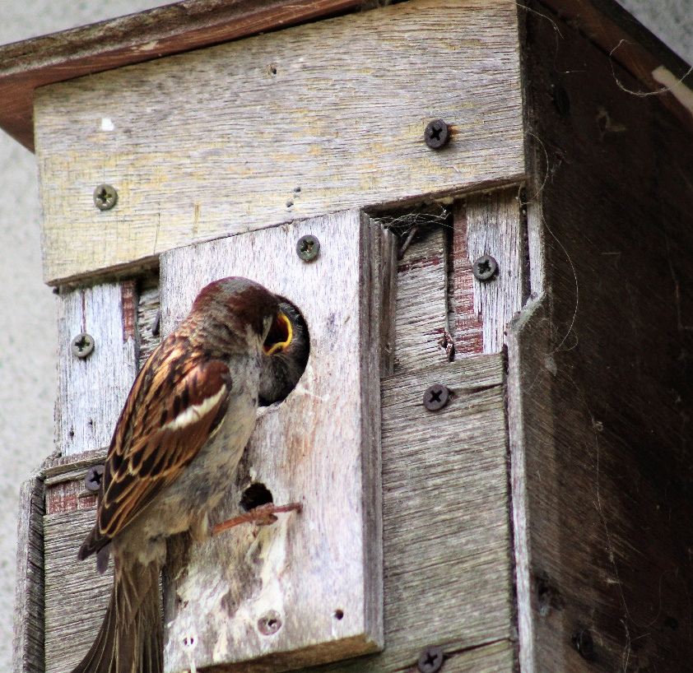

A nesting bird being fed Breda Joyce

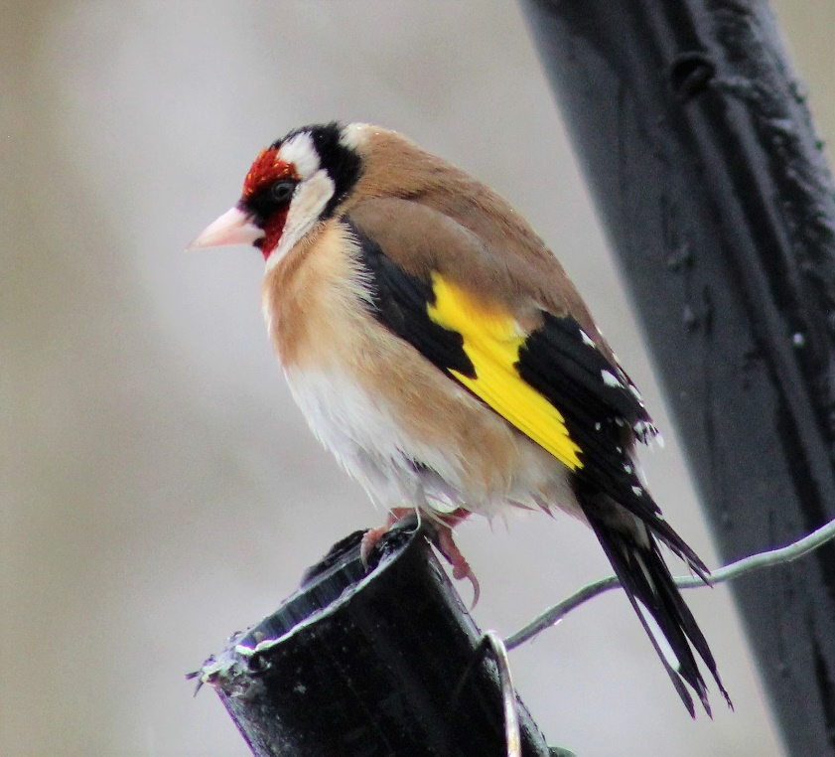

Goldfinch Breda Joyce

Bus Number 8
Something between the stare of sustained eye, touch of lip, hurls a silent meteorite into the stir of suspended time.
Space licks visceral reflex, searching and yearning for what was lost so long ago but recovered in one, breathless, traffic light of recognition.
We become one again, smiling briefly. Recognising our ghosts at rooted intersection, Lights turn green and we go home. Elemental to human - flames to candlelight.
Infinity pours into hot glass of steamed bus. Your finger traces x before you disappear...
Catherine Ronan

Night Bus

It is impossible to cry quietly
upstairs on the night bus.
Rain mirrors her face
in a dull orange glare.

But nobody notices
or seems to care if they do.

Pain sits like a stone
in her belly – she wants
to spit, to be sick.
There is only the glass
between her and the night.

Brian Kirk

Fluture

mă port pe mine
prinsă
c-un ac de siguranță
de oglinda mea
tăiată din sticla unui vitraliu reciclabil
ce cu spărturile lui
strică atmosfera din biserică
și trec pe-aici
ca o pereche de fuste
croite-n colțuri
cu pliuri și imprimeuri
pe care vântul se căznește mereu
să le ridice

Butterfly
(Translated from the Romanian)

I carry myself
pinned
with a safety pin
to my mirror
cut out from a recyclable stained glass
that with its holes
disturbs the atmosphere in the church
and I am passing by here
like a pair of skirts
tailored with corners
creases and prints
that the wind is always striving
to lift

Anamaria Julia Dragomir

Mayfly
Ephemera danica - Heroum

To rise
Emerge delicately
Out of the deep after a year or maybe two
Dusk to dawn
Like the first flying insects
Wispy tails
Upright lacey wings
The final moult
Dull dun to translucent green

Males swarm above the lake
Performers in fading light
Females join the dance
Rising and falling,
Elongated front legs locate
Grab her in a pas de deux
Mate mid air
He releases she descends
Dips down lays eggs into water

Spent Spinners float into morning
Outstretched wings and legs
Just for one day

Teresa O’Connor Diskin

The Embalmer

The embalmer is an illusionist –
death’s Santa Claus.
His gift is to restore
how we once looked
for our loved ones,
to replace our haunted bodies
with the softness of those
who sleep easy.
He halts death’s lessons
and our learning.
In those moments of ease,
we are robbed of
death’s vital preparation
and, in the end,
it is us who pays
the hefty price.
We pay thrice,
once to the embalmer,
then by not being present
and finally by fearing
our demise.

Alice Doyle

Bedrock
A rock star lies
beneath this rock

so fans leave flowers
and empty bottles.

Some sage scratched
these lines in the dirt nearby:

Sometimes the flames
of fame burn out.

Sometimes the fame
fills quarries.

Frank William Finney

Kodachrome

Currachs on seaweed beds like idling seals
lie waiting for the tide to breathe in, rise.
The light’s calligraphy of rusty dulse a spiel,
a pull. Late sun airbrushes chromatic skies.

On the quay lobster pots pose in blue and green
while buoys sport red. In the fisherman’s hut
a hanging yellow raincoat cheers the sheen
of an unused lifejacket on alert. I must rebut:

John Hinde did not sell an Irish tale of sham.
He just didn’t look beyond. In a lobster pot
a plastic bag. I list for the scientist’s cartogram:
torn tackle, swim bait, Tayto bag and flip flop.

Against the X-rays of stark sun a different hue:
the gannet’s stomach is a shine-through blue.

Karin Molde

On reading Olav Hauge, I realise
I never wanted the whole truth – only, just a hint

truth is pinch of salt rubbed into an old wound
truth is Palo Santo sprinkled on a dying charcoal

truth is the one-legged pigeon begging in red square
truth is your gift of red tulip bulbs still left unplanted

truth is last night’s dream forgotten
truth is last night’s dream unspoken

truth is two blue lines on a piss-stick
truth is a toddler waking at night

truth is coveting my neighbour’s wife
truth is my wife coming home on time

truth is taking the long way home
truth is that extra few minutes in the bathroom each day

truth is a late-night text from an old lover
truth is deleting texts before bed

truth is the dreamed of kiss
truth is the kiss gone cold

truth is the last fire from winter’s windfallen sticks
truth is a piece of yesterday’s story that has died

truth is a night cap after bed
truth is not being able to sleep
truth is a magpie laughing in the morning
truth is a blackbird dead by the kitchen window

truth is a lie I have not yet confessed
truth is the sound of your crying in the shower

truth is your unopened letter
truth is the empty church of your patience

truth is promising never again
truth is praying when it’s too late

truth is you never said goodbye
truth is you left

truth is this – me here alone – and missing you
truth is at best only ever half-remembered.

Fergus Hogan

Moonlight

Red moon of summer evening
August heatwave lasts apace
Cows bark like jackals
The queen dwells cool in residence
Her standard fluttering high
Strange messages linger still
Peace descends in silent waves
Old dragon winks wisely through the fields
Fingers of celestial clouds
Invade virgin sky

O heavenly father I have sinned
I forgot to bring the bins in
We sit and smoke the heavenly nectar
Music that brings sweet sleep down from the blissful skies
The dragon rises again
A powerful monster living down in the darkness
The hidden one appears for a moment’s turn
The holy one’s true self slips out to speak
Sixteen again back in that Deutschland garden.
He stares at the clouded moon

Kenneth Hickey

Night-time in November

At the drive thru we discuss the subtle
differences in Americano, Macchiato, Cappuccino,
as a host of ravenous perverts survey us from the car park.
There’s a warmth on the air.
I tell you we’ve changed even the smallest details
of our environment; how there are more nocturnal animals
than just the golden mange of a city fox,
that at the drive thru, none of these seagulls will sleep tonight,
hardwired now to our slightest hand movements in the car.
But I want to tell you more,
that in a field a forty-gallon cast iron pot sits,
as a relic to colder times, used now as a drinking trough for cattle,
a pot once used for making soup, into which a quarter- pound
of leg of beef would be tossed; and how we would gather
in our rabble
with the sleepless half-cocked
stare of a seagull,
watching for that twitch and pour,
for any sudden hand signals.

Vinny Glynn-Steed

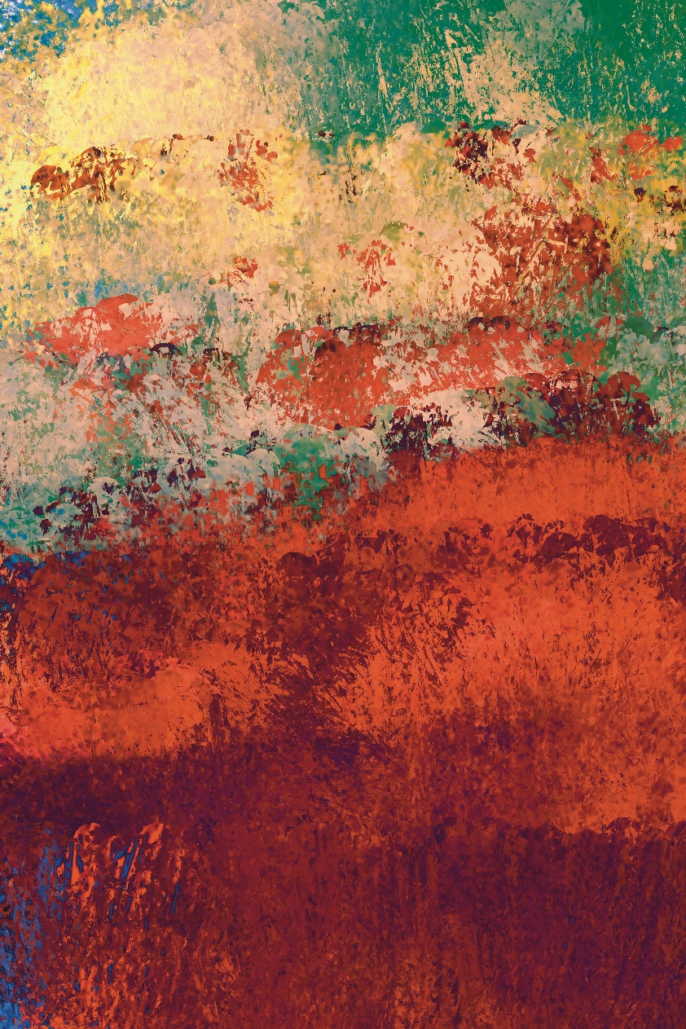

Gathering the Approaching Times Edward Lee
Notes on Contributors

Mandy Beattie frequently loses herself in poetry & imaginings. She’s been published in numerous journals such as Poets Republic, Lothlorien, Ink, Sweat & Tears, Dreich, WordPeace, Visual Verse, Wildfire Words, Spilling Cocoa by Martin Amis, Last Stanza, The Haar & more. Short story in Howl New Irish Writing, Poets Choice, Marble Poetry. Shortlisted, Black Box Competition.

Dr Arthur Broomfield is a poet, short story writer and Beckett scholar. He holds a Ph.D in English literature from Mary Immaculate College, University of Limerick. His current collection is Ireland Calling (Revival Press). Arthur is Poetry Ireland Poet Laureate for Mountmellick.

Eamon Cooke’s collection Berry Time was published by Dedalus Press.

Bernie Crawford’s poetry has been published extensively including in New Irish Writing in the Irish Times, Poetry Ireland Review, the North magazine, Mslexia, Banshee, Stony Thursday Book among others. Her debut collection Living Water was published in 2021 by Chaffinch Press. She is a co-editor of the popular poetry magazine Skylight 47.
Deirdre McKernan Crosby lives in Greystones Co. Wicklow. Writing for 5 years, she is published in the Bray Arts Journal, Boyne Berries Literary Journal, The Blue Nib and Pendemic.ie. She has also produced and read, My Home My Place, Seabourne View with own illustration as part of Poetry Day Ireland 2020. Deirdre has contributed towards PDI events in Greystones in 2021 - ‘23.

Máire Morrissey Cummins is writing poetry since 2010 and is widely published in print and online. Her favourite poetry is haiku, a Japanese short form. She loves nature and lives close to the sea in Glengarriff, in West Cork where she has recently retired. She paints watercolours, a mindfulness exercise daily and she loves to explore local history and folklore of the Beara Peninsula. She plans to plant a garden of 3 acres for the next ten years.

RC deWinter’s poetry is widely anthologized, notably in New York City Haiku (NY Times, 2/2017), Coffin Bell Two (Coffin Bell, 1/2019) The Connecticut Shakespeare Festival Anthology (River Bend Bookshop Press, 12/2021), in print: 2River, Crossroads, Event, Gargoyle Magazine, Genre Urban Arts, Meat For Tea: The Valley Review, the minnesota review, Night Picnic Journal, Plainsongs, Poetry South, Prairie Schooner, The Seventh Quarry Magazine, Southword, The Ogham Stone, Variant Literature, York Literary Review among many others and appears in numerous online literary journals.

Teresa O’ Connor Diskin’s poems were published in Skylight 47 (Issues 12 &15), The Galway Review (Issue 9), Dodging the Rain (September 2019), Vox Galvia (July & September 2020), Spilling Cocoa Over Martin Amis (April 2021), Irish Farmers Journal (May 2021), Reach Poetry (Issue 277), Poetry in Lockdown Archive, U.C.D. and she was shortlisted for Poems for Patience 2019 and 2022.

Brought up in rural County Clare Anne Donnellan lives in Galway. Her debut poetry collection Witness was published in December 2022 by Revival Press Limerick. Anne’s work has appeared in several poetry journals including Boyne Berries, the Bangor Literary Journal, Skylight 47, Drawn to the Light Press, Orbis and the NUIG Ropes Literary Journal.
Alice Doyle is an intuitive, transformational, and prophetic existential Poet. She writes about the Soul, nature, her late discovery that she is autistic and multiply neurodivergent, her struggles with existential awareness, belonging and trust, and the quest to find our truest paths in life.
Anamaria Julia Dragomir is a Romanian citizen residing in Ireland who came to Ireland in august 2013 and was charmed by its places and its people. Her education and formation include a BA in Romanian and English Language and Literature (Babeș-Bolyai University, Faculty of Letters, Cluj-Napoca, Romania) and an MA in Ancient and Medieval Philosophy (Babeș-Bolyai University, Faculty of History and Philosophy, Cluj-Napoca, Romania). Being fascinated by literature, she is also trying her pen at writing verse.

Michael Durack lives in County Tipperary. His work features in journals such as The Blue Nib, Live Encounters, The Waxed Lemon, The Honest Ulsterman, and Poetry Ireland Review. His collections are Where It Began (2017), Flip Sides (2020) and This Deluge of Words (2023) from Revival Press.

Clare Fagan is twenty-one-years old, a writer from Mullingar in County Westmeath. Some of her poems have been published in The Westmeath Examiner (January 2021) and Get a Grip Publishings (March 2023).

Attracta Fahy, Psychotherapist, MAW NUIG ‘17. Winner-Trócaire Poetry Ireland Competition 2021. Irish Times; New Irish Writing 2019, Pushcart & Best of Web nominee, shortlisted for: Saolta Poems for Patience 2023, Fish International Poetry Competition 2022, Write By The Sea Competition 2021, Dedalus Press Mentoring Programme 2021, Allingham Poetry both 2019 &’20, OTE 2018 New Writer of the Year. Her poems have been published in many magazines and anthologies at home and abroad. Fly on the Wall Poetry published her debut chapbook collection Dinner in the Fields, in March’20. She received an Agility Award from the Arts Council 2022 and is presently working towards a full collection.

Frank William Finney is a poet and retired lecturer from Massachusetts who taught literature in Thailand for twenty-five years. He is the author of The Folding of the Wings (Finishing Line Press, 2022) and other collections. Follow him on Twitter @FinneyFw.

Maeve Heneghan is from Co. Dublin. She spent some years teaching English in Beijing and Chongqing in China. She currently lives in Co. Laois. Her poetry has been featured in A New Ulster, Headstuff, The Galway Review, The UCD Special Collections Archive and most recently, Tír na nÓg.

Kenneth Hickey was born in 1975 in Cobh, Co. Cork Ireland. He served in the Irish Naval Service between 1993 and 2000. His poetry and prose has been published in various literary journals in Ireland, the UK and the United States including Southword, Crannoig, THE SHOp, A New Ulster, Aesthetica Magazine and The Great American Poetry show. His writing for theatre has been performed in Ireland, the UK, New York and Paris. He has won the Eamon Keane Full Length Play Award as well as being shortlisted for The PJ O’Connor Award and the Tony Doyle Bursary. He was shortlisted for the Bournmouth Poetry Prize in 2022. He has been selected for the Poetry in the Park project and has been awarded a poetry mentorship by Munster Literature Centre. His work in film has been screened at the Cork and Foyle Film Festivals. He holds a BA and MA in English Literature both from University College Cork. His debut collection ‘The Unicycle Paradox’ was published by Revival Press in November 2021. He still resides in Cork.

Drogheda-born Ciarán Hodgers is a multi-award winning spoken word poet living in the UK. His debut collection Cosmocartography was shortlisted for the Rubery Book Award 2019 and toured the UK & Ireland. His forthcoming collection, Solastalgia, will be published by Burning Eye Books in November 2023. http://www.ciaranhodgers.com/.

Fergus Hogan’s poetry chapbooks have been highly commended, twice, in the Fool for Poetry International Chapbook Competition. In 2019 his chapbook, Bittern Cry, was published. In 2021 Fergus was a recipient of a Munster Literature Centre Mentoring Fellowship. His prose/memoir writing Snowbird was published in Channel.

Breda Joyce grew up in Headford, Co. Galway and taught at second-level in Kenya, Clifden and in Cahir, Co. Tipperary. On retiring from teaching, Breda studied creative writing in UCC where she won her first poetry prize and graduated with an MA in 2020. Her work has been twice shortlisted for the Anthony Cronin and the Over the Edge Awards. She has been shortlisted for the Fish Lockdown prize 2020, the Desmond O’ Grady award 2021, Best of the Net 2021, the Francis Ledwidge prize 2021, 2022 and Allingham 2022. Her short collections have been highly commended in the Fool for Poetry Chapbook competition 2019 and 2020. Her poetry appears in various publications, anthologies and literary journals, including Poems for Pandemia and The Best New British and Irish Poets Anthology 2019-2021, and in The Irish Times, and she has broadcast on Sunday Miscellany. Apart from writing Breda enjoys Irish folklore, sea-swimming and hiking in the hills near her home. Reshaping the Light published by Chaffinch Press 2021 is her first poetry collection.

Maeve Keane is a writer and teacher based in Cork. She graduated from the MA in Creative Writing at UL in January 2023. Maeve writes both poetry and prose, and her work features in Swerve Magazine, Ropes Literary Journal, Oranges, The Storms, The Ogham Stone, ShorterStories.ie and on several podcasts. She can be found on Instagram @mabbit, and at www.MaeveKeane.com.

Noel King was born and lives in Tralee, Co Kerry. His poetry collections are Prophesying the Past, (Salmon, 2010), The Stern Wave (Salmon, 2013) and Sons (Salmon, 2015) and Alternative Beginnings, Early Poems (Kite Modern Poetry Series, 2022). He has edited more than fifty books of work by others (Doghouse Books, 2003-2013) and was poetry editor of Revival Literary Journal (Limerick Writers’ Centre) in 2012/13. A short story collection, The Key Signature & Other Stories was published by Liberties Press in 2017. www.noelking.ie.

Brian Kirk has published a poetry collection After The Fall (Salmon Poetry, 2017) and a short fiction chapbook It’s Not Me, It’s You (Southword Editions, 2019). His poem “Birthday” won Irish Book Awards Poem of the Year, 2018. His novel Riverrun was a winner of the Irish Writers Centre Novel Fair 2022.

Sven Kretzschmar hails from Germany. His work has been published internationally, e.g., in Writing Home, The ‘New Irish’ Poets (Dedalus Press, 2019), Hold Open the Door (UCD Press, 2020), Das Gedicht, The Irish Times and more. He was awarded 2nd place at the Francis Ledwidge International Poetry Award 2022.
Edward Lee is an artist and writer from Ireland. His paintings and photography have been exhibited widely, while his poetry, short stories, non-fiction have been published in magazines in Ireland, England, and America, including The Stinging Fly, Skylight 47, Acumen and Smiths Knoll. He is currently working on two photography collections: 'Lying Down With The Dead' and 'There Is A Beauty In Broken Things'. He also makes musical noise under the names Ayahuasca Collective, Orson Carroll, Lego Figures Fighting, and Pale Blond Boy. His blog/website can be found at https://edwardmlee.wordpress.com.

Alison McCrossan is from Cork. Publications include Orbis, Southword, Stand Magazine, Drawn to the Light Press, Crannóg, and The Honest Ulsterman.

Melanie McDowell makes sense of her world through words. Through poetry she threads her internal and external landscapes together. Melanie lives by the sea in West Kerry with her husband, three young boys and dog. Melanie studied English Literature and Philosophy at Trinity College Dublin and after forays in travel, setting up a business, and starting a family, she is finding her way back to words through poetry. Melanie has volunteered with Fighting Words and has been involved with the Dingle Literary Festival. Melanie has been encouraged to share her unpublished work after mentorship with Enda Coyle-Greene through the Irish Writers Centre and her continuing mentorship with Máire Holmes through Kerry Arts Council. Melanie has had her poems published in The Galway Review and has completed her first collection of poetry.

Karin Molde feels at home in Ireland and Germany. She loves rough places, rocks, and a strong wind pulling when she is walking the beach. She teaches languages and has published in magazines, both print and online, like Skylight 47, Honest Ulsterman, The Wild Word, and in anthologies. Her chapbook “Self-Portrait with Sheep Skull” is out with Moonstone Press, 2023.

Patricia Anne Moore, originally from Belfast, lived there until she moved to Killaloe in Clare. She began writing poetry as a member of Killaloe Writers Group. She has had work published in journals such as Force 10, Pendemic.ie and in several editions of The Stony Thursday Book. She is working towards a first collection.
Catherine Ronan holds a degree in French and Applied Psychology from University College Cork and has been writing poetry since childhood. In 2020 she returned to UCC to study creative writing. She is a member of multiple Poetry Collectives and is on the DeBarra’s Spoken Word Team. She performed her translations of Rimbaud and Victor Hugo for the Cork World Book Festival 2023. Her work is being exhibited as part of the Poetry in the Park and Heritage Projects. Long listed for Cúirt New Writing in 2023 and accepted for the Long Island Sounds Anthology, NY. She lives in West Cork with her husband, three children, two cats and a goldfish!

Craig Shalvey is a twenty-seven-year-old man from Galway, living in Dublin. He has been previously published in Tír na nÓg and the Dark Poets Club. Craig fell in love with poetry at a very young age and cites Sylvia Plath, Anne Sexton, Philip Larkin, Eavan Boland and Dr Maya Angelou as his major influences. His work explores themes of mental health, Irish identity and queer love bringing a unique perspective to these subjects that is both deeply personal and relatable.

Gail Sheridan is a writer who lives in Waterford with her family. Gail works in community development and writes poems and short stories.

Kris Spencer is a teacher and writer. He was brought up in Bolton. He has lived in the city and the country, and in the UK and USA. He currently lives in West London. Kris has poems published in journals in the UK, US, Europe, Eire and SE Asia. His debut collection, Life Drawing (2022), is published by Kelsay Books.

Vinny Glynn-Steed from Galway is widely published. winner of the 2020 Allingham poetry competition, his debut chapbook Catching Air was published the same year.

Anthony Wade, a Forward Prize nominee, has published poetry in Ireland, Britain, India, the US, and Canada. London-born Irish, he now lives by the sea in East Cork close to where he spent childhood summers and is an active member of the local writers’ group. twitter.com@anthonywadepoet.

Gerard Walsh began writing poetry in 2019, has since been published in Writers Forum and was a runner up in Trim Poetry Competition 2022. A part-time library assistant, he lives in rural co. Kildare, from where he enjoys growing and selling seasonal cut flowers.
Wendy Webb loves nature, wildlife, symmetry and form and the creative spark. Published in Reach, Sarasvati, Quantum Leap, Crystal, The Journal, The Frogmore Papers; online in Littoral, Lothlorien, Autumn Voices, Wildfire Words, Atlantean; broadcast Poetry Place. Forthcoming: Dreich, Leicester Literary Journal, Seventh Quarry. Book: Love’s Floreloquence; Landscapes (with David Norris-Kay) from Amazon; free downloads of other poetry from Obooko. Love's Floreloquence: Amazon.co.uk: Webb, Wendy Ann, Meek, CT, Meek, CT, Webb, Wendy Ann: 9798372967595: Books.

Mandy Beattie Arthur Broomfield
Eamon Cooke Bernie Crawford
Deirdre McKernan Crosby Máire Morrissey Cummins
RC deWinter Teresa O’Connor Diskin
Anne Donnellan Alice Doyle Michael Durack
Anamaria Julia Dragomir Clare Fagan
Attracta Fahy Frank William Finney
Maeve Heneghan Kenneth Hickey
Ciarán Hodgers Fergus Hogan Breda Joyce Maeve Keane
Noel King Brian Kirk Sven Kretzschmar
Edward Lee Alison McCrossan Melanie McDowell
Karin Molde Patricia Anne Moore
Catherine Ronan Craig Shalvey Gail Sheridan
Kris Spencer Vinny Glynn-Steed Anthony Wade
Gerard Walsh Wendy Webb

€15
ISSN 2737-7768
