Drawn to the Light Press

Issue 10

October 2023

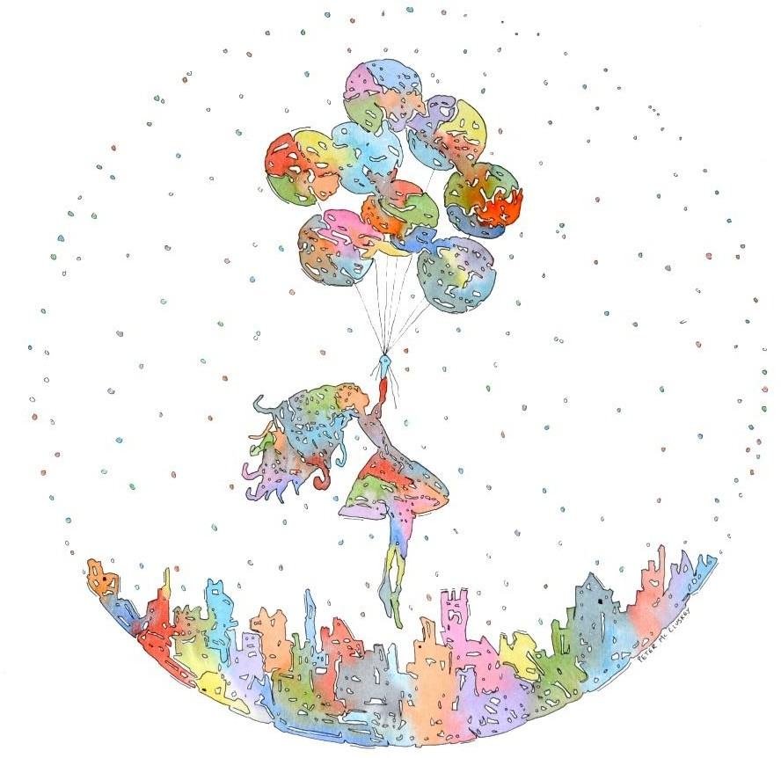
Uptown Girl Peter McCluskey
Contents

How to escape without leaving | Bobbie Sparrow | 5
Life is too short | Rachel Coventry | 7
Je m’exclame | James Finnegan | 8
Brainsick | Ali Rowland | 9
The Death of Sand | Gerard Walsh | 10
Supermoon | Adrian Fingleton | 12
The Precession of the  Equinoxes | Felicia McCarthy | 13
Negotiating Borders | Bairbre Meade | 14
Around 8 in the Morning on  April 14th | Craig Cox | 15
Oyster | Joseph Boyle | 17
Americano | Jessica Berry | 19
still rolling | K.S. Moore | 20
Postcard | Alan Murphy | 22
Ghost | Brian Kirk | 23
Coda | Alan Murphy | 24
Life is the art of the probable | Tomás Ó Ruairc | 25
Le Lac | Sara Mullen | 26
Poetry Competition Shortlist |  | 28
Umbrella Girl | Peter McCluskey | 29
Retrospective | Honor Duff | 30
Night Gifts | Denise Blake | 31
Drawn to Winter Light, Robin  (Golden Shovel form) | Wendy Webb | 32
Recurring Dream Within  Recurring Dream | Gearóid O’Brien | 34
Lady With An Ermine | Alan Murphy | 36
Waiting | Faye Boland | 37
Rockets Are Dreaming of You | Polina Cosgrave | 38
In the Dark we Dream in Haiku | Nollaig Rowan | 39

Someday This Will All Make  Sense | Lorraine Mc Ardle | 40
Elsewhere | Tim Dwyer | 41
Dreaming of Fighting, Again | Shane Leavy | 42
Autumn Leaves | Adrian Fingleton | 44
Notes on Contributors |  | 45

Editorial

Welcome to issue 10, October 2023. It’s been 3 years since the founding of Drawn to the Light Press which took its name from my debut chapbook, Drawn to the Light, in turn called after a poem within that book. Having served my apprenticeship as an editor of Boyne Berries and after the pause of the pandemic, it seemed a natural step forward to create a new magazine.

The 10 poems shortlisted for the Hold Fast to Dreams Poetry Competition are included herein. Thanks to everyone who entered the competition and to all the contributors to the issue.

Of the cover design, Uptown Girl, Peter McCluskey writes, "I have been very interested in and influenced by street art. Street art has become commonplace in most European countries and is actively encouraged by city authorities. My piece is reminiscent of this style of ‘outdoor art’...it consists of simplified composition, clean lines, mostly primary colours bordered by graphic pen.”

Thank you to the reader for reading.

Orla Fay 22/10/2023

How to escape without leaving

You may be standing at the kitchen sink, a toddler dribbles on your leg,
the lasagne you hate burns in the oven.

Put on your shell -pink Louboutins.

Perhaps you stand by your boss’s desk in a skirt that digs into your waist, listen
as he drones about his golf trip in Costa Navarino.

Spit in his coffee, piss in his plant.

Or you are slumped in the upright chair at the nursing home, your father’s hands
palm down on a baby blue quilt; he dribbles.

Recall the broth he made when you had hepatitis.

You may notice a loss of time in the bath, skin flushed from thoughts of a lover’s hands, as your husband installs the new kitchen.

Fill the cupboards with oysters, strawberries, chilli and figs.

You are a shoe maker who can only wear sandals
due to severe Psoriasis, you stroke slim heels in tears, each ping of the customer bell induces acute envy.

Hire several small elves.

You live in a bedsit above a chipper in Co. Louth, the mattress smells of old sex and feet,
you are fifty-seven and your son hates you.

Join a poetry writing workshop.

Your breasts feel empty, your sex an unreliable creature, you don’t say you want to set yourself on fire.
Yet, the future always makes you feel thirsty. Book a Boudoir session and buy a vibrator. Bobbie Sparrow

Life is too short

I always liked you
but you married someone else.

Time slipped by indifferent as a cat.

We’d have an occasional chat once a year or so

huddled in a door way to shelter from the wind,

the never-ending rain.
Now, at the first of our peers’ funerals,

you speak over me three times. I am relieved you have

silenced her, not me these last 20 years.

Rachel Coventry

Je m’exclame

An exclamation mark is like a baseball and a baseball bat.
It is like the spot southwest of Robert De Niro’s right eye when Bob faces you coupled with someone lying on the floor speaking through the side of their mouth uttering those dark utterings.
It is like a hot air balloon made from crude oil or dark ink.
It is like a keyhole where the key
fits in the top above a full stop with depth.
It is a silhouette of the last drop of blood from a worn-out earth bleeding upward where gravity has undergone an inversion
along with that final bead
of sweat on a very very hot day

James Finnegan

Brainsick

Shakespeare had a word for it, of course, not a flowery Latinate term,
not deep with layers of hidden meanings, not DSM-appropriate, but more immediate. Imagined as a faint green hue just visible and, seemingly, creeping across
the pickled specimen in its misty jar.

In any case, not referring to something easily shrugged off, like ‘low mood’ or ‘over-thinking.’
Clearly a malady to be dreaded for its dim and yellowed humor, its lack of simple antidote,
and tendency to recur. No ointment can salve it,
no parted flesh heals with time alone,
it is insidious, lurking, defiantly unwell.

Ali Rowland

The Death of Sand

She turns the heated iron
in the crucible and pulls out her first clear gathering

the same as he taught her after school or skipping class they loved to spin, mold

or cut to make a bowl. An amorphous glob,
she rolls it on the marvel

the shape of a bullet. She didn’t see it coming, the whiskey at the start

still god-like with glass until xanax and blackouts ruined the clean lines

and he came to a dead-end.

She blows air in and caps the pipe with her thumb

overcoming the furnace is slowly healing,
pulling petals from the orb

blowing these clear flowers, the breath of the glassmaker and her father in every piece.

Gerard Walsh

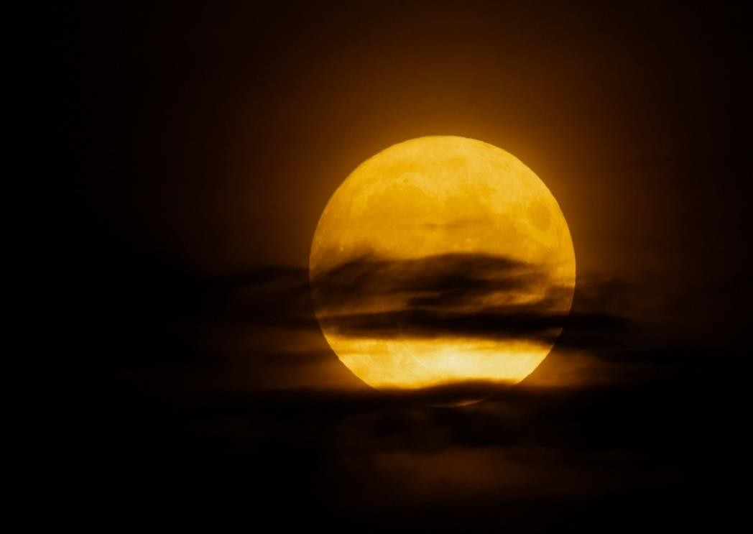

Supermoon Adrian Fingleton

The Precession of the Equinoxes

There was always going to be a reckoning. Inhale, exhale, examine the ebb and flow of tide.
Watch the moon's effect on the water, on your own changing energy, thoughts, your pride.

The fall and rise were written in at the start.
We make theatre, poetry, and art from the pain of misunderstanding the bigger picture. Consider
the outer planets, solar winds, the moon’s white shadow.

Each full spin of the axis lasts thousands of years.
Each turn upward on the spiral brings another reckoning of truth, half-truths, and the inevitable uncovering of lies.

Felicia McCarthy

Negotiating Borders

The blackberry bush has colonised the garden, no ordinary settler, an explosion
of thorns that prickle through every crevice,
permeates through every bush, weaves through fronds, manoeuvres over grass and cement

from plant to shrub. Conquering every inch.

The other plants continue growing, thorns keeping them safe
from human hands.

My only option is to go nuclear. Destroy from the root, obliterate the innocent herbage caught in the fallout.
The entire garden levelled. And begin anew.
Bairbre Meade

Around 8 in the Morning on April 14th

Osso is watching Caitriona half listen
to the news that a sliotar just missed Joe Biden
and I’m reading “The Letter” (by Lydia Davis) which is essentially about
how slow and sudden change can be.

Drawn curtains bracket pale morning sky.

The purple leaves of false shamrock reach for heat.

A potted vine’s cascade masks my uncle’s end table which was only let inside
if unseen.

To be fair,
he also gifted the rocking chair
that sits well below a row of John Kelly prints and might someday be referred to
as “Craig’s”.

Mostly,
you’re focused on programming the new cat feeder

so as not to worry about my forgetting while you’re away.
This must mean we have a system.

It hasn’t been a week since I decided to move.

But to misquote a comment overheard from an interview
discussing Sinead O’Connor’s vilification:

“There is no guarantee things will change
if you try
but there is a guarantee that they won’t
if you don’t.”

Craig Cox

Oyster
(freshly shucked, in a shot glass with vodka, lemon juice and cocktail sauce, $3.95/ea)

I tip the glass and nod
to my new friend at the bar. I sing with a rolling gut, salute with useless limbs.
Greasy fingers dance across the checkered tablecloth
of the Acme Oyster House.
Gelatinous eyes
twinkle in the dim light.

Bless these kidneys, lungs, liver and gall!
The stain of some excess calcium silently dissolves inside me

The oyster is my great- great grandfather. He lent me this spine. He tumbled
from ocean to net, crate to plate, from blue sunshine in the gulf to a neon grave

It’s not fair that I still breathe air and am shuttled back and forth over land. You don’t limp anymore across the salty floor,
and your mandalas in the sand are brushed away over time

I know time will come
for me. I’ll meet you in the end, nod again, as we drift into
the hole at the bottom of the sea

Joseph Boyle

Americano

At the barista’s insistence:
“This one’s on the customer in front of you” Reflecting in a twirling lake of milk, a face flooded

Red peonies, their soft, curvaceous figures, left in the doorway Prompted that first patron to electric kindness
Always flirting at the edges of his mind now: her

Lips, tickling as if brushed by wet feathers, feeling February’s chill
An earnest Valentine lost all pretences, embraced spontaneous kindness When gifted an assertively purple woollen coat, adroitly stitched

Together, holy knitters and natterers
Blessed their community as they were blessed
By blushing cheeks of cherry trees, shading their fingers

Tip to tip – indexes touch through vinyl gloved hands
Newly adopted palliative family tried to transfer magic to the botanical man At the hospital bedside, in hopes he would wake

Up and away, on a no return trip to our bowl of bone moon Sinatra’s voice put him in a buoyant mood
To buy an Americano for the nurse behind him in the queue

Jessica Berry

still rolling
‘A cemetery where I marry the sea’ — Red Hot Chili Peppers

the sea too vast
to bind by words pours from my grasp

vows breaking.

I only hold
its chill inside bear the scent of its bitters.

Graves follow us their eyes
the names
of floating somebodies.

I catch them
in my open arms the sea
still rolling from me.

Every time it turns I feel
the bed is piled with washed up grit

tiny stones

of early days
that should have been set in a ring

before losing shine.

K.S. Moore

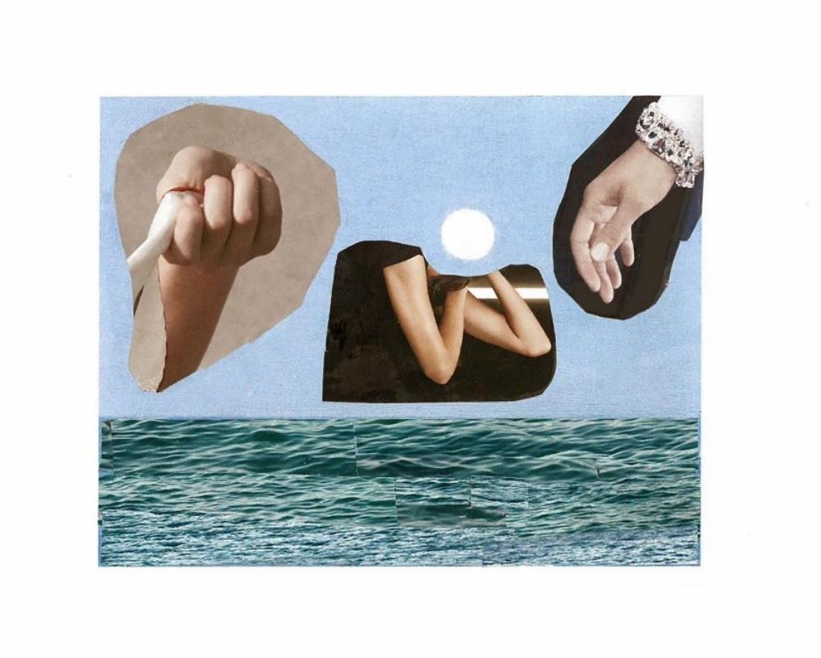
Postcard Alan Murphy

Ghost

I view the present in the light of past while understanding things can never last; the essence of events is warped by time,
so yesterday’s dull chores become sublime when observed by future me. Looking back the aspect alters as I try to track
my movements. Am I subject or object of the story, unable to effect
real change? Trapped in a timeless bubble, lapped once again by my faceless double,
it won’t be long before my cover’s blown – I long to be a verb but am a noun.
In fact, I could be parasite or host,
no longer real and yet not quite a ghost.

Brian Kirk

Coda

Broken sunglasses on an empty beach
in a Leonard Cohen song that loves the shade.

On an empty beach someone walks away that loves the shade and its cool anonymity.

Someone walks away to the sound of music and its cool anonymity is broken by a voice.

To the sound of music a weather-beaten heart is broken by a voice as the tide goes out.

A weather-beaten heart, broken sunglasses,
as the tide goes out
in a Leonard Cohen song.

Alan Murphy

Life is the art of the probable

where dew drops poise on leaves,
calling you to canal bank edge, balance by path while you toy with the thought of looking back,
falling more — where horsetails, clover, buttercups and dog shite cluster and clamber in the middle zone between a river made up as it goes along and
a gravel grazed way. I trace them in my timing eye beyond the
lock gates to dock and sea —where I stood one morning in the shine of a cycle by beech and chestnut, chest heaving, heart beating
in rhythm with all the golden leaves before me.

Tomás Ó Ruairc

Le Lac

There you were, the eye in my mind, the sky in passing admiring itself
in you.

There you were, far away from me,
mauve, maybe slate, black, perhaps grey, maybe blue.

There you were,
in one of your moods: serenely faraway, fiercely perturbed, freezingly still.

There you were, holding together your Mayo trove

of old water and secrets.

Meantime,
in Paris, an actor took my lines and unbeknownst to you, there you were.
Sara Mullen

Hold Fast to Dreams Poetry Competition Winners (Overall winner – Rockets Are Dreaming of You – Polina Cosgrave)

Retrospective by Honor Duff Night Gifts by Denise Blake
Drawn to Winter Light, Robin (Golden Shovel form) by Wendy Webb
Recurring Dream Within Recurring Dream by Gearóid O’Brien
Waiting by Faye Boland
Rockets Are Dreaming of You by Polina Cosgrave In the Dark we Dream in Haiku by Nollaig Rowan Someday This Will All Make Sense by Lorraine Mc Ardle
Elsewhere by Tim Dwyer
Dreaming of Fighting, Again by Shane Leavy

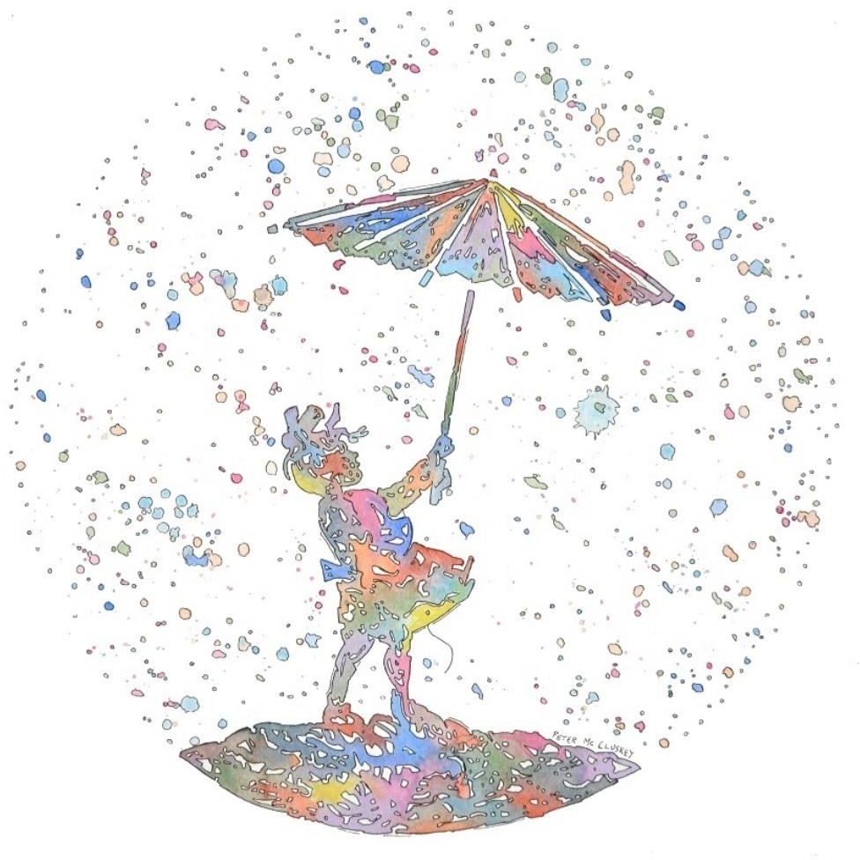

Umbrella Girl Peter McCluskey

Retrospective

There is the running dream where Octogenarian me moves swiftly on winged feet across city pavements to catch a bus, which of course I do with ease; or I'm kicking up sand as I run beside the sea, and sometimes across a stretch of meadow grass, exultant to find joy in swiftness, something I once thought lost.

When our beloved dead appear in dreams, we take it for granted. My brother always in his garden,
My sister, her beautiful self again; she and I visiting a carnival
at some indeterminate seaside place.
We jump onto the painted horses
as the band plays “Over the Waves”. Maybe Dreamland is Tír na nÓg,
and like Oisín, I fell awake, then aged.

Honor Duff

Night Gifts

Gift me a dream full of lightness,
Not in candy floss sweetness that melts
Into sugared words. And not a dream of fluffy Cloud emptiness that dissolves into tears. ‘What’s for you won’t go by you’.

Gift me a dream of yeast bread baking
As the smell fills my childhood-home memories. Or gift me a four-course dream laid out before me To heal a deep hunger, a dream as red as a cabernet Fortifying my blood, replenishing lost strength.

A dream that will charge like a wilful bull Through locked gates and imagined obstacles,
For obstinance and courage with no urge to back down. A dream where I am the leader, my backbone built
By generations before me to bolster my spirit.

Gift me a dream of a choir singing, just for me,
So I know I am not alone. A dream of a summer’s day, basking under rays of pure hope. A dream of ruby shoes To guide my steps towards a warm-hearted destiny.
A bouquet of dreams, and I will sleep a deep slumber.

Denise Blake

Drawn to Winter Light, Robin (Golden Shovel form)

Flush youthful aspirations – paved gold –hold my centre/self/ego, soon breathing fast
to City life, new sights, good friends, to watch the ever-flowing Thames of dreams. Hope/despair – in equal measure – for success/failure reveals secret hurt. Then, if
my background, full of roses’ thorns, casts dreams
to wish away frail petals in a storm, or die, bravely raising sails – like bird wings – life sparkles with the sky, the sea. So scenic is hope’s hot air balloon, it bursts, a
rush of flutter, claws; bats left broken-
hearted. I escape. Laughing gas, to buoy fresh-winged tomorrows. Finding love and life as broad as bird
…droppings. Farne Isles – so artistic – that foul mud/sludge/tide/Tsunami cannot dampen passion when it’s moist to fly.

Dream hell a thousand times: I fly. The pewter dreams are crowding into past nightly, lightning flashes warnings. Is
my body’s ageing spent? All dreams are such
phantoms into dawn. I bravely wake a
Boudicca, to broadly storm revenge. How curious that my nature’s blue as sky. What creature aspires – a Phoenix fire-spent. What to
do? Beacon-red, a lighthouse, won’t you look
at my pert new persona (him or her);
so berry-brave, I love bugs, worm round in
a Gardener’s happy place. The spade, the

trowel glow my singing best. Seaming face, all feathers from the stars. Now I find a mellow fog, uplifting heavenly transport to ward off Winter blues. My crimson may breast all of earth its seasonal reward.
May my sound warm and happiness Spring us gentler dreams at end of day to sleep. Or, frozen into earth, when offspring bring a rooting/shooting new song. That is no disgrace.

Wendy Webb

NOTE: [‘Hold fast to dreams/for if dreams die/life is a broken-winged bird/that cannot fly.’ Langston Hughes; and ‘The past is such a curious creature, /to look her in the face./A transport may reward us,/or a disgrace’ The Past, Emily Dickinson]

Recurring Dream Within Recurring Dream

…. fade
My voice surprised me. Escaping from an angry soul I bellowed at the naïve people Hiding one behind the other.

In the convent garden The besotted guardian,
His pig’s-cheek washed down With chilled Frascati
Recalls in a dream
An almost empty Spanish beach.

A child is screaming Unquenchable screams And continues to scream

His dream is getting good now, Her bronzed back tantalises him Bikini briefs. Petite.
She turns and
Her pert breasts point accusingly

The child is in a paroxysm Cannot catch its breath Instead it gasps
And continues to gasp

The sins of our childhood Are now as nothing.

Our ancestors fasted And continued to fast
Yet he grows fat presuming Always on our generosity.

He turns on the seat trembling But hopes to stay asleep.
She stares at him
And continues to stare. As the convent bell tolls.
Her breasts turn to sour apples On an over-hanging branch.

My angry voice fades And continues to…

Gearóid O’Brien

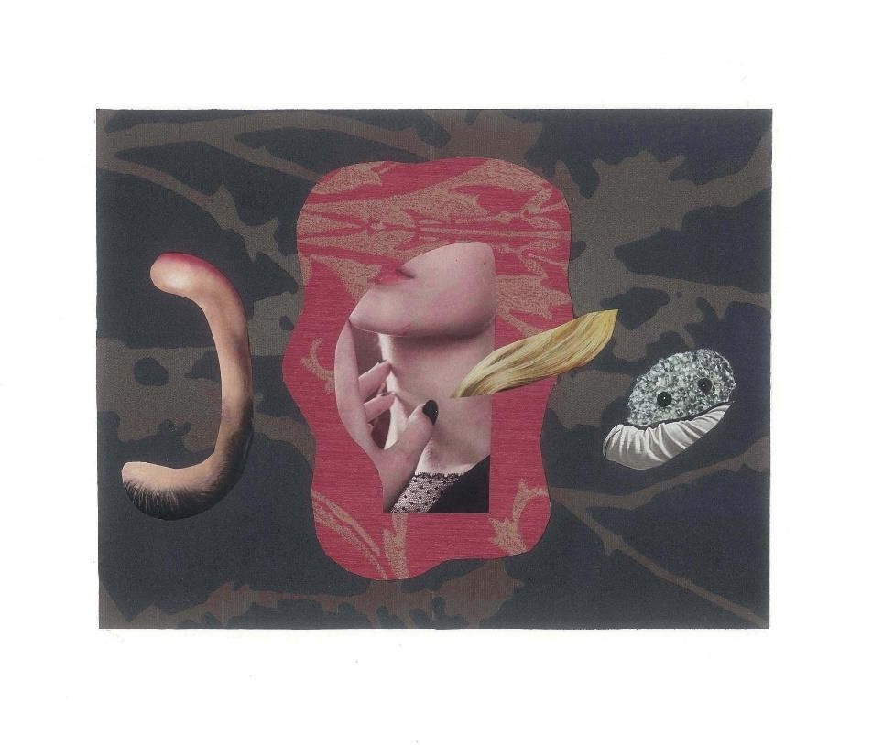
Lady With An Ermine Alan Murphy

Waiting

Last night you came to me in a dream.
Adoring eyes fixated on my face as I leaned into yours,
holding you in the crook of my arm.

You were dressed in blue, symbolising boyhood, perhaps? And we were seated on a bench in a university lecture theatre.

I felt the bliss of unconditional love as we sat smiling, compacted together like twix in their packet. Silent, yet
understanding one another completely.

Nothing mattered. Neither lectures, nor money nor housework. My pre-menopoausal age
was not a consideration. High blood pressure and pre-eclampsia irrelevant.

And when I awoke, surprised and elated this dirty dishwater morning,
I knew that somewhere near,
almost within reach of my fingertips you are waiting.
Faye Boland

Rockets Are Dreaming of You

Writers are dreaming of poems, Rockets are dreaming of space. Chessboards are dreaming of pawns, I haven't dreamt for days.

Lovers are dreaming of kisses. Clowns are dreaming of tears. Wake me from this, sweet Jesus, I haven't dreamt for years.

Soldiers are dreaming of grenades. Children are dreaming of flight.
I haven't dreamt for decades. Wake me and lend me your light,

So I can be like writers, Rockets, lovers and soldiers. So I can watch my nightmares blossoming over my shoulder –

These children were dreaming of grenades. Those soldiers were dreaming of flight.
The country is cursed for decades, and no one can sleep at night.

Polina Cosgrave

In the Dark we Dream in Haiku

Friday night power cut darkens our island
sets us apart phones dim batteries fade action is urgent
when time is limited
messages honed to three-liners bounce from home to home

candle flames flicker
shadows follow round the room a step back in time

Fire-makers card players transistor-listeners
early-to-bed mates no Netflix no cuppa no electric blanket
no night-light comfort
in the morning no power for shower no breakfast tea no hot-buttered toast

twelve-hour starry night Sherkin Island off the grid dreaming in haiku

Nollaig Rowan

Someday This Will All Make Sense

Yesterday’s River flows backwards, lifts your head off a mulberry silk pillowcase, drags you through a wrought iron fence.

Drops you into the foyer of the Nowhere Museum where wicker dragons hover overhead,
their jaws open ready to swallow you whole.

But this is a joyful dream, someone shouts from the gods,

and then you find yourself on stage in the Olympia Theatre reciting lines from Hamlet that you learnt
for the Leaving Cert in ‘92.

Why are you in the nude? they catcall

at your naked body perched on the Mermaid’s Rock, polished granite shining like diamonds.
You will not find your Magnum Opus if you wake up

before you crash through checkpoints or toll bridges. Keep going. Keep driving steering from the back seat.
The cat will stare through the window and wait for you to blink.

But do not feed him. Let Evening Primrose glow and suck saffron from its stamen. There will be a happy ending where cut glass sopranos slice the air and eyes shine like sapphires.

Lorraine Mc Ardle

Elsewhere
Over the stone wall there’s a field of corn
and I’m back on the Ohio road beyond town, where farms begin
thousands of miles and years from here.

Time shrinks. I’ll never return,
though from a dream bus window the sign for Vermillion,

I pull the cord for the next stop

Tim Dwyer

Dreaming of Fighting, Again

I overhead a man in a café say:
‘I dreamed I was fighting again, last night.’
He blinked, scratched the smooth dome of his head, and his cardiganed wife said: ‘Oh dear, again?’ Then: ‘Could you pass the pepper, please, John?’ John did and sighed, a small man, worn down.
‘I don’t know why I keep dreaming of fights
in my sleep, when I’ve never had one, in my life.’

‘That’s why,’ said his wife. ‘You’re anxious about it. I used to have dreams about driving –
before I got my licence.’ They were drinking
tea, well-milked: faces warped in the teapot’s steel.
I returned to my book. Steam rose
from my coffee mug, steam hung and swirled around stern waitresses, sweeping; steam beaded and slid down the rain-chilled windows.

Then clap and gasp, I turned and at a table a young girl held a hand to cheek,
her boyfriend rose, red-faced, I heard him say: ‘Don’t talk back to me, you bitch.’ He raised his hand, the café stilled,
eyes locked on the towering man, fists clenched, my insides a twist of guilty dread,
then little John said: ‘You leave her be.’

Astonished, the red-faced bully twisted, shoved the older man against the wall, cried: ‘Mind your own business!’ but John,

in tight voice, said: ‘I’m not scared of you.’ The beast whipped back his head to butt,
but John lunged first and the man’s descending nose struck, with a crack on the old man’s forehead.
John staggered back, the boyfriend flopped to the floor,

and scrambled up, chest splashed with running red, then stared at John, with his fat fists clenched,
and fled. ‘Are you all right, pet?’ said his wife to the girl and the room relaxed; John coughed, and sat.

Shane Leavy

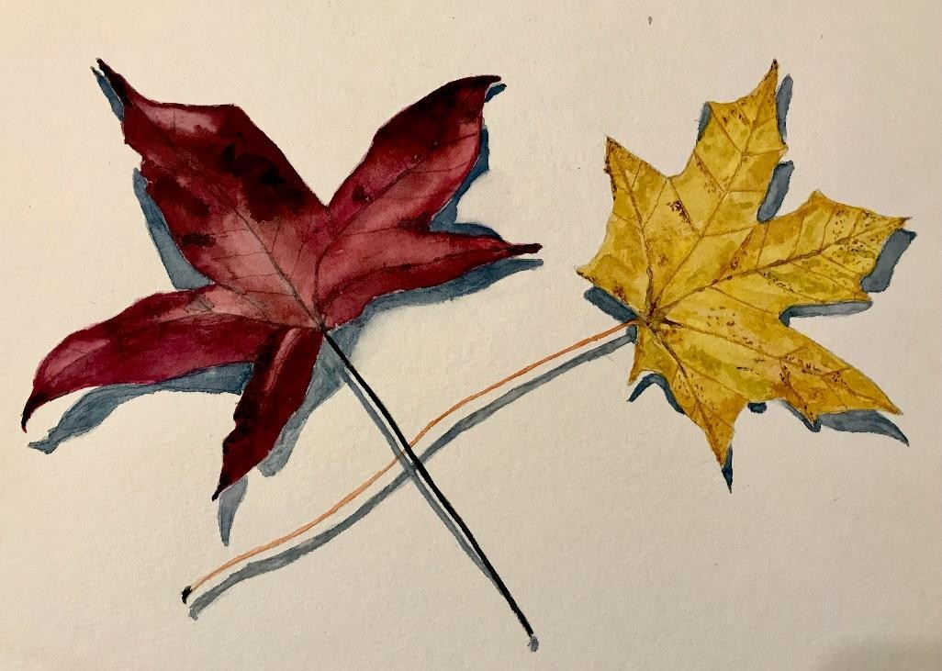

Autumn Leaves Adrian Fingleton

Notes on Contributors

Jessica Berry is an English teacher from Northern Ireland. In 2021, she was placed in Bangor’s annual poetry contest hosted by the Aspects Literary Festival and recently she placed second at the Fingal Poetry Festival slam. Her work has also been included in publications such as Drawn to the Light, A New Ulster and Rust & Moth. Social media links: @jessicaruth.poetry on Instagram.

Denise Blake was born in Ohio, USA and lives in Co. Donegal. Her poetry collections, Take a Deep Breath and How to Spin Without Getting Dizzy, are published by Summer Palace Press. Her third collection, Invocation is published by Revival Press. Denise is a regular contributor to Sunday Miscellany.

Faye Boland won the Robert Leslie Boland Prize 2018 and the Hanna Greally International Literary Award 2017. She was highly commended for the Desmond O’Grady Prize 2019. Faye was shortlisted for the Irish Times National Poetry Award 2022 and the Poets Meets Painters Award 2023. Her poetry collection Peripheral was published in 2018.

Joseph Boyle lives in Sacramento, works as a counsellor, and spends his free time metabolizing sugars and admiring the way wind moves through trees. He holds an MA in Creative Writing from University College Dublin. His poems have appeared in Fahmidan Journal, Book of Matches, The Madrigal, The Stony Thursday Book, and others.

Polina Cosgrave is a bilingual writer and Arts Council award recipient based in Ireland. Her debut collection My Name Is was published by Dedalus Press. Polina features in the Forward Prizes Book of Poetry 2022. Her work has appeared on TV, radio and in numerous journals and anthologies.

Rachel Coventry lives in Galway. Her poems appear in The Guardian, The Rialto, The North, Stand, and The Moth. Her second collection, The Detachable Heart (Salmon Poetry), was published in 2022. Her monograph Heidegger and Poetry in the Digital Age: New Aesthetics and Technologies (Bloomsbury) will be published in December.

Craig Cox is a sound artist and poet working all over Ireland. His work, both independent and collaborative, has been hosted by various arts festivals and radio stations but he has only once before been published. This was on an episode of the podcast Eat The Storms. Examples of his work can be heard on his Bandcamp page.

Honor Duff, a Dubliner living for almost 20 years in Co. Cavan, has had her poetry published in a number of journals such as Boyne Berries, Crannóg, Skylight 47, The Stony Thursday Book, The Galway Review, and Windows Publications. Her work has been placed and commended in various poetry competitions.

Tim Dwyer's poems appear in Irish and UK journals/anthologies, recently/forthcoming in New Irish Writing, Masculinity Anthology (Broken Sleep), Cyphers. His chapbook is Smithy Of Our Longings (Lapwing). He grew up in a diverse working-class neighbourhood in Brooklyn, NY, and now lives in Bangor, Down.

Adrian Fingleton is a keen photographer, based in Dublin, and his favourite subjects are Wildlife and Landscapes. Since retiring on the eve of the pandemic in early 2020, he has been exploring ways to translate some of his photo-subjects into art, and he mostly works in the medium of watercolours. He also loves travel and tries to bring a sketchpad with him to capture some impressions of the places he visits.

James Finnegan, Dublin born, second-prize winner in the 2022 Gregory O’Donoghue International Poetry Competition, second-prize winner in the 2022 Allingham Poetry Competition. A collection of poems, The Weather-Beaten Scarecrow (Doire Press, 2022) was shortlisted in the Farmgate Café National Poetry Award in April 2023.

Brian Kirk has published a poetry collection After The Fall (Salmon Poetry, 2017) and a short fiction chapbook It’s Not Me, It’s You (Southword Editions, 2019). His poem “Birthday” won Listowel Writers’ Week Poem of the Year at the Irish Book Awards in 2018. His second poetry collection Hare’s Breath is due from Salmon Poetry in Autumn 2023. www.briankirkwriter.com

Shane Leavy is a writer and creative writing facilitator in north Leitrim. His work has featured in Abridged, Trasna, Popshot: The Illustrated Magazine of New Writing, Icarus, Infinite Worlds Magazine and Jacked Crime Anthology. He is the winner of the 2022 Poets Meet Painters Award.

Lorraine Mc Ardle was awarded the Poetry Prize at Listowel Writer’s Week in 2022, and Highly Commended in the 2022 Fool For Poetry Chapbook Competition and the 2019 Hippocrates Prize for Poetry and Medicine. She is widely published including Poetry Ireland Review, The Irish Independent, The North, and Southword.

Felicia McCarthy is a poet living in Dublin, Ireland. Her poems have appeared in print and online literary zines in Ireland, USA, UK and Mexico. In 2020, she was The Blue Nib’s North American Time Poetry Editor. Salmon Poetry is bringing out her collection My Country is the Whole World in 2023.

Peter McCluskey is a contemporary fiction writer from Dublin, Ireland. He has published four contemporary fiction novels to date. Peter is also a songwriter and music composer and has just completed a commission from Kildare County Council to create ten new pieces of Irish Traditional music and songs. Peter is an established watercolour artist and has participated in numerous national exhibitions as well as working on a variety of commissioned works.
Bairbre Meade’s first book For the Love of Ireland was published by Summersdale Press. She came 3rd in the Katrina Ellis Memorial Prize limerick competition. She has had two articles published for Generation Emigration, The Irish Times Online, ‘Feeling Isolated in a Strange New City’ and ‘Door to Door’.

K. S. Moore was chosen for Poetry Ireland Introductions 2022 and placed third in the Waterford Poetry Prize 2020. Poetry has recently featured in New Welsh Review, Ink, Sweat and Tears, The Honest Ulsterman and Skylight 47. Her debut collection What frost does under a crescent moon is forthcoming with The Seventh Quarry Press.

Originally from Castlebar, Sara Mullen lives and teaches in Dublin. Her work has featured in Burning Bush 2, Crannóg, Boyne Berries, The Cabinet of Heed, FLARE, Poethead, Visions International, The Crowstep Journal, BlazeVOX and The Journal, and in the anthologies A Thoroughly Good Blue and Tearing Stripes off Zebras.

Alan Murphy is the writer-illustrator of four collections of poetry for children and teenagers. He has contributed poetry and visual art to numerous digital and print journals and anthologies in Ireland, the UK and the US, and exhibited

throughout Ireland and abroad. Dublin born, he lives in Lismore, county Waterford.
www.avantcardpublications.com

Gearóid O’Brien is a retired senior executive librarian and author from Athlone. His poetry has been published widely including Crannóg, Cyphers, Boyne Berries, The Shot Glass Journal (USA), StepAway Magazine (U.K), The Stony Thursday Book and the anthologies I Live in Michael Hartnett and Chasing Shadows.

Tomás Ó Ruairc lives in Lucan, Dublin with his wife, Sara, and four daughters. He blogs at Sifting the Silence on Bazinga
- https://bazingadotlife.wordpress.com/. He is new to Drawn to the Light and has published the poem Conker in the Cathal Buí Poetry Publication 2021.

Nollaig Rowan, poet and short fiction writer has had work published in Incubator, Skylight 47, Boyne Berries, From the Well, Angle and other journals. She's regularly featured on RTE Radio 1 Sunday Miscellany. One of her poems was selected in this year's poems for patience competition. Nollaig divides her time between Dublin and Sherkin Island, West Cork.

Ali Rowland is a poet and author from Northumberland. Her poetry is sometimes about her own mental health issues and sometimes about the world in general. She is assisted in her endeavours by a wonderful husband and a beautiful Border Terrier. Ali won the Hexham Poetry Competition in 2023 and has been published in Tabula Rasa: Poems by Women (Linen Press): Ten Poems of Kindness Vol. 2 (Candlestick Press): Dreich Magazine, The Frogmore Papers, The Journal, Amsterdam Quarterly and Obsessed with Pipework.

Bobbie Sparrow is a widely published poet with poems in journals and anthologies. She was nominated Dodging the Rain’s best published poet in 2018/19. Her work has been placed in several well-known competitions. She loves swimming in lakes and believes curiosity keeps her alive. Her debut collection is due for publication by Yaffle Press in Spring 2024.

Gerard Walsh is from Donadea Co Kildare. His poems have been published in Writers Forum, Drawn to the Light Press, Apricot Press and he was a runner-up in Trim Poetry Competition 2022. He is a part-time library assistant, who also enjoys growing and selling seasonal cut flowers.

Wendy Webb loves nature, wildlife, symmetry and form and the creative spark. Published in Reach, Sarasvati, Quantum Leap, Crystal, The Journal, The Frogmore Papers, Dreich, Leicester Literary Journal, Seventh Quarry; online in Littoral, Lothlorien, Autumn Voices, Wildfire Words, Atlantean; broadcast Poetry Place. Book: Love’s Floreloquence. Love's Floreloquence: Amazon.co.uk: Webb, Wendy Ann, Meek, CT, Meek: 9798850867003: Books.

Editor: Orla Fay

Published by Drawn to the Light Press
ISSN 2737-7768
Next issue: February 2024
https://drawntothelightpress.com
Twitter: @DrawnPress
Instagram: @drawntothelightpress
Facebook: @drawnpress22

Patrons: Anthony Wade
Arthur Broomfield
Attracta Fahy
James Finnegan
Simon Lewis


Drawn to the Light Press is edited, designed, and produced by Orla Fay.

Cover design Uptown Girl by Peter McCluskey.

The works included in this issue are copyright of the poets and artists ©2023 and may not be reproduced or changed in any way without the permission of the individual author.

Drawn to the Light Press is ©2023 of the editor. All rights reserved.

Drawn to the Light Press Issue 10
October 2023
Bobbie Sparrow Rachel Coventry
James Finnegan Ali Rowland Gerard Walsh
Adrian Fingleton Felicia McCarthy Bairbre Meade Craig Cox Joseph Boyle
Jessica Berry K.S. Moore Alan Murphy Brian Kirk Tomás Ó Ruairc Sara Mullen
Honor Duff Peter McCluskey
Denise Blake Wendy Webb Gearóid O’Brien
Faye Boland Polina Cosgrave Nollaig Rowan
Lorraine Mc Ardle
Tim Dwyer Shane Leavy

€15
ISSN 2737-7768

