Drawn to the Light Press

Issue 5

February 2022

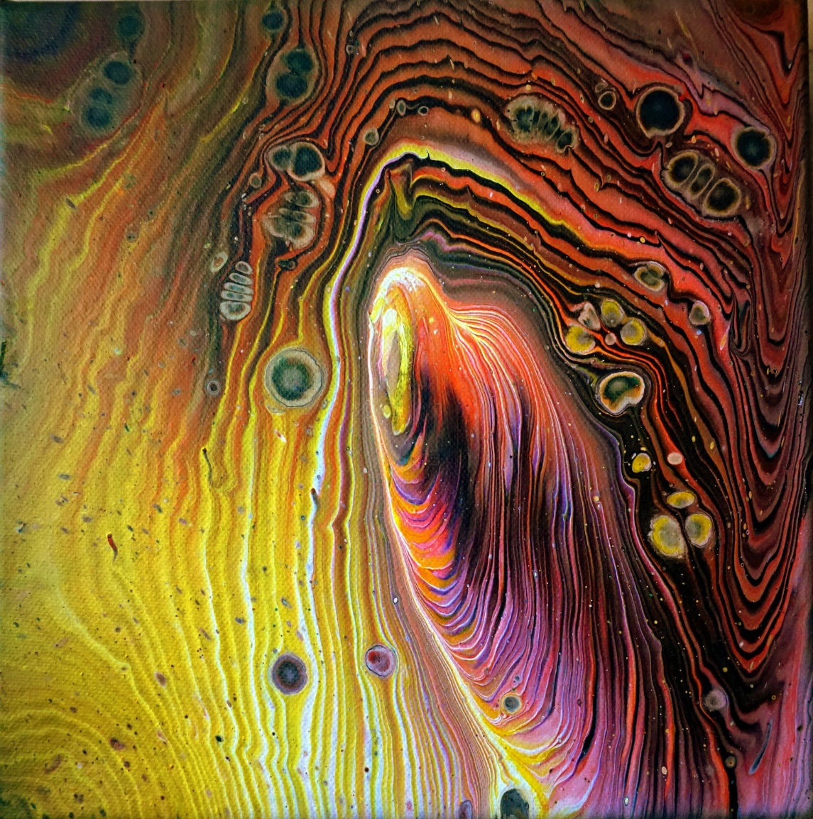

Luminous Journey Acrylic on canvas Anna Freyne

Contents

Don’t Forget (You Deserve It) | Leah Keane | 4
Perfectly Altered | Leah Keane | 5
What I Do Not Want | beam | 6
Withdrawing | Clara McShane | 7
Frailty | Ross Thompson | 8
Month’s Mind | Christa De Brún | 9
The Hope of Eternity | Edward Lee | 10
Like George Herbert | Barbara DeCoursey Roy | 11
Darn | Emily Cullen | 12
Quietude | Cheryl Vail | 13
Accumulation | Jan Starkey | 14
Regret is a Blade of Snow at my Window | Maeve O’Reilly McKenna | 15
The Third Winter | Breda Wall Ryan | 16
Winter dreams | Sven Kretzschmar | 17
Magnification | Sven Kretzschmar | 18
The Magpie and the Sycamore Leaf | Attracta Fahy | 19
The Artist | Attracta Fahy | 20
To Spend Time with Love | Honor Duff | 21
Bloom | Anna Freyne | 22
Seed Season | Siobhán Mc Laughlin | 23
Tin box | Cathy Fowley | 24
After Reading Jack Gilbert, 316 | Fergus Hogan | 25
Kathleen | Liam McNevin | 26
Sunday | Ion Corcos | 27
Spaghettification | Carolyn Claire Mitchell | 28
Breaking News | Eugene Platt | 29
Dublin’s Eye | Victory Luke | 30
Young Boy | Oisín Breen | 31
she wasn’t royalty, she was a woman | Jessica Anne Rose | 32
Unwell | Jim Ward | 34
Joyce | Jim Ward | 35
Mary, at the Gable End | Geraldine O’Sullivan | 36
Still | Lindsay McLeod | 37
Life | Katherine Noone | 38
Light and Dark Hearts | Edward Michael Supranowicz | 39
Sour | Brian Kirk | 40
Ode to Yellow | Kris Spencer | 41
Summer Meadow | Anna Freyne | 42
Atelier des Lumieres | Kate Ennals | 43
Lists | Ellen Skowronski-Polito | 44
Sleeping on the Beach | S.C. Flynn | 45
Blue and Green Dreams | Edward Michael Supranowicz | 46
Reefpoint | Philip Davison | 47
At Dollymount, skimming stones | Eithne Lannon | 48
A Question (after Zora Neale Hurston) | Danica Ognjenovic | 49
Distance Nothing More | Edward Lee | 50
Earth Tides | Sinéad McClure | 51
High Seas | John D.Kelly | 52
Robbed | Marie Studer | 53
Heaney and Frost | Jessica Berry | 54
On Ashford Hill | Richard Devereux | 55
What The Day Asks For | Edward Lee | 56
Notes on Contributors |  | 57

Editorial

Issue 5 is dedicated to the memory of Ashling Murphy who was killed on the afternoon of January 12th, while jogging on the banks of the Grand Canal at Tullamore, County Offaly. Within, Jessica Anne Rose’s poem she wasn’t royalty, she was a woman recalls the death of Sarah Everard. Kate Ennals’ poem Running in Circles from issue 3 is worth revisiting in this context of violent crimes against women, femicide, as the media has brought into the zeitgeist.

I am ever grateful to the artists and photographers who lend such colour and nuance to the page. Anna Freyne on this occasion framed the zine with Luminous Journey.

As I have documented in my Facebook updates, whilst curating the magazine, the introduction to the poetry of Jack Gilbert in Fergus Hogan’s piece, and to the odes of Pablo Neruda by Kris Spencer were welcome. Thanks, Sinéad McClure for teaching me about earth tides. Thanks to Attracta Fahy for her dedication to Sacha Hutchinson whose work featured in issue 1, and for Kabir’s poem

Breath

Are you looking for me? I am in the next seat.
My shoulder is against yours.
You will not find me in stupas, not in Indian shrine rooms,
nor in synagogues, nor in cathedrals:
not in masses, nor in kirtans, not in legs winding around your
own neck, nor in eating nothing but vegetables.
When you really look for me, you will see me instantly—
you will find me in the tiniest house of time.
Kabir says: Student, tell me what is God?
He is the breath inside the breath.

It’s no secret, or it shouldn’t be now, that I feel closest to anything that is divine, which I would call spirit, when I am writing or engaged in creative work. I think in all these poems included there is a call to the spiritual, to the great we know not what for guidance. A hunger. It could be what Chase Twichell called “the dogs of the self” in her poem Hunger for Something. I suppose it’s that old knowledge our mothers taught us, we come into this world alone and we leave it alone, and in between we must come to a reckoning with ourselves and mortality, “It’s not the appetite an army has / for its own emptying heart”, Twichell wrote. It certainly is not. It is a great call to the universe, a lending of voice to a choir that existed long before us, which will exist far after. It’s good to be a quiver, a vibrato, a pen mark, a key tap, a brush stroke. A thought. A breath. Take heart.

Orla Fay 27/01/2022

Don't Forget (You Deserve It)

You hope one more bottle will help
because, after all, this is the opposite of bottling it up.

But this is how it helps: it doesn't.
The only thing it does is transfer the hurt.

It leads to a friend messaging you on Facebook at 1am
to remind you of things you never remembered
and never thought you could be capable of.

It leads to you pulling out that musty pack of cigarettes
and smoking until your lungs bleed

because suffering is the only way to ask for forgiveness
without a forgiving word being said.

It leads to waiting for hours for an answer to an apology
and knowing you deserve every second of suspense
because your time is now hinged on regret.

It leads to an hour spent on Reddit threads for alcoholics
and thinking about your dad in another hospital bed.

It leads to never knowing
until you've learned to lie in it.

Leah Keane

Perfectly Altered

As the day quickens and my heart slows
I will never forget the air in that room
pulled tight between us
waiting to be released by worded lever,
but grasped by hands that do not matter

because they are not ours.

I cannot count the times
I have laid that night out flat
like a blanket
and placed my fingers through the holes I have made
that make it perfect.

When you revisit a memory often enough,
you cannot help but alter it.
We are simple creatures, victims of our own beliefs
tinkering with the mechanics of a life
that bends us to desires

it has no intention of letting us reach.

Leah Keane

What I Do Not Want

Shelves.
I can’t bear the weight of what I have
sitting out in front of me
photographs facing me
visually tracing me then
and what I’m not now.

I want us to ruin something sacred.

Why do I want that? Then what?

What do I think will happen
when I go down the same road
I’ve gone down before
end up in the same place
as every other turn has taken me,
there’s no one making me.
But I’ve decided again

I want us to ruin something sacred.

In doing so feel the votive divinity
like a tight little glove
like the grip is real
or at least feel again

Now I just smell the smoke of the lie.
Why do I want this
like I’m intended to be burnt
as an offering or a symbol
the fulfilment of a vow
and the vow is this:

I could never be sacred without you

beam

Withdrawing
On glummer Tuesday evenings
I sketch you,
mottled pages of my marbled trinket notebook
filling in the hazy contours of your face.
Sometimes, my crude pencilling widens
the gulf between your eyes and nose,
(it’s like that, with drawing)
and I force a brilliant laugh, or two,
painting the pretence
of a purposeful impressionist.
I draw your hands behind your back, at times,
or not at all.
Drawn hands look sausage-like, to me,
cartoonish and scrawly,
and simplistic, given that you are real, now
to something.
Six weeks ago, you removed me
from your virtual darkroom of developments
of living sketches glowing in screaming red.
I sketch you, still, erasing the tiny twisted lines
that jolt from my wicked pencil,
summoning your homely eyes,
digging pensive holes into the brittle paper,
alternating my hands with yours.
On Wednesdays, I pass the grimy orange bus-stop
and count inanimately
collecting, with each step, a store of solid sketches,
sleeping trees, cars,
things without hands,
to draw closely behind you.
Clara McShane

Frailty

i.m.

How it must have felt for you, then and every day,
hanging from a wire so thin it made your head swim
to contemplate this cruel nature of quavering.

What bravery it took to shoulder such frailty:
the devil who kept step on this precarious
stave, who diverted your path with nefarious
lies and weighed heavily upon your plundered frame.

From the gate, you found your way paved with black poppies
and bitter water: the badlands where temptation
staked a claim for your good name and spared you no grace.

That awful truth scratched into the clay of your heart:
few of us know just how close to the edge we are.

Ross Thompson

Month’s Mind

November shade stills me,
hours of light scattered by sun’s
slumber, bequeathing the night
to Hesperus and the grieving sky.

November, the month of saints and souls.
Months mind, as though grief begged our pardon
before stealing the light of a thousand days
and wrapping it in vespers.

November, still-a-shiver at dawn
the bearer of light floods the horizon,
sunrays dropping down the bare branches,
trust in the gold dappled grass.

Christa De Brún



The Hope of Eternity Edward Lee
Like George Herbert

Prayer is a bargain for the skin-flint heart. A hymnal singing in a hijacked
brain, empty folding chairs before a stage. Words with soul, like basso ostinato.
The uses of refrain.

The soldier waving with his phantom arm, tire marks where the pickup
missed the fawn, flagons of light spilling tears on a burned out lawn,
a teenage girl unaware of her charm.

The silence of a prelapsarian age. No past to hold our gaze, no prisoners
to crucify, no jealous god to praise. A universe unconscious of itself.
A self, unconscious of its song.

Barbara DeCoursey Roy

Darn

We mend what we love.

After ten fruitless minutes
of squinting through spectacles
to thread through the miniscule
eye of a needle, I delve

deeper into my sewing kit
for one with a larger slit,
backstitch into the fray
where the tear begins,
start to patch a white petal
on my black floral dress.

I feel like Dorothy Wordsworth
who devoted hours to darning
and transcribing, darning and
transcribing as image and

rhythm unspooled
but no doubt she was neat
where my effort is crude.
Now I spot that I forgot

to turn the cloth inside-out.

Emily Cullen

Quietude

she wasn’t a seamstress by trade
I was smaller than the gap in her thimble

quieter than the tap of her needle against the pewter
or the pull of the thread as she hemmed the denim

I was the personification of a patience that
wouldn’t have materialized if I had learned to sew

and when her fingers could no longer thread the needle
I never knew such solace again
nor ever had a pair of jeans fit so well
Cheryl Vail

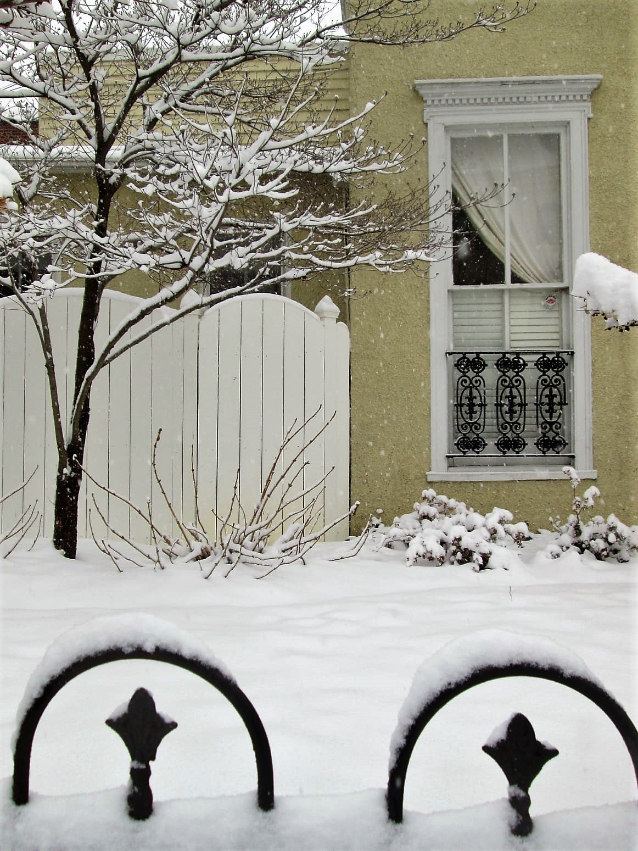

Accumulation Jan Starkey

Regret is a Blade of Snow at My Window

Beige; a bland interlude against
the prism of this window. I never
said I couldn’t be loved, but

love deadens the scent of you, love.
Trees re-imagine weather
on sensational arms.

Bushes brace under tentacles of hope.
I am wrought in black,
no escape from complicated latches,

a twig picking brittle locks
in my metal garden. The fence
is beautifully iron, curtains flaunt

invitations like a novice.
Shadows import the body’s vision
of itself. Thumbs run amok

over the splinters of erect panels.
Day contracts, night expands
like wet wood.

A trinity of owls grimace
under woeful tiaras. Who will prime
their breasts with paint in the spring?

I have interred a memory to
this vision of regret; snow
dazzling as a blade at my wrist.

Maeve O’Reilly McKenna

The Third Winter

Earthworms freeze in dank soil,
slugs slither down, layer by layer,
closer to Hades’ fire. They gleam,
pallid globules on the roots
of the pomegranate tree.
Only the dream sustains me:

Demeter unwraps two straw-wound
wine apples. Ember-lit on her palms,
they shine, red-streaked lanterns.
She saves me the choicest, as if
even now I might lean into her flank,
lay my head in her lap as her blade
splits the fruit, explores the folds
of its juice-swollen womb.
She flicks bloodripe droplets
into the pink cave of my mouth
with a halfmoon thumbnail.
I crush them one by one between
teeth and tongue, release winejuice
in exquisite increments.

Earth Mother, all winter I yearn
for sap-rise, to walk with you
through pomegranate fields,
ripening the glistening fruit.
Your mourning overwhelms me.
I stretch my dazed mouth
for a wine-rich seed, taste
slug, bitter as cloudberry.
This is our third winter sundered.

Breda Wall Ryan

Winter dreams

Do you believe there is still a song for you and me?
What incantation will resound, softly, when the barrel organs
of child and dogs and daily routines fall silent?
In the dead of night, which names will we mumble,

silently, to our own auricles and hearts?
In winter dreams a plank door outing towards a plane
of snow, footsteps leading away, re-enters memory –
my usual haunt. Where I wait for you to come

plodding back through the cold high white. Crystalized water,
that much I know for a fact. Waking into a glum bedroom
I think of my day walks, gales exhaling a smack in the face,
a hushed melody fading somewhere in the back

of my mind. And of that dream cabin. I do believe
there’s still a song for you in me. I need you to help me
serenade it right. For now, my incantation is the rough solitude
of bark and leaves, of walks in woods and winter wind.

Sven Kretzschmar

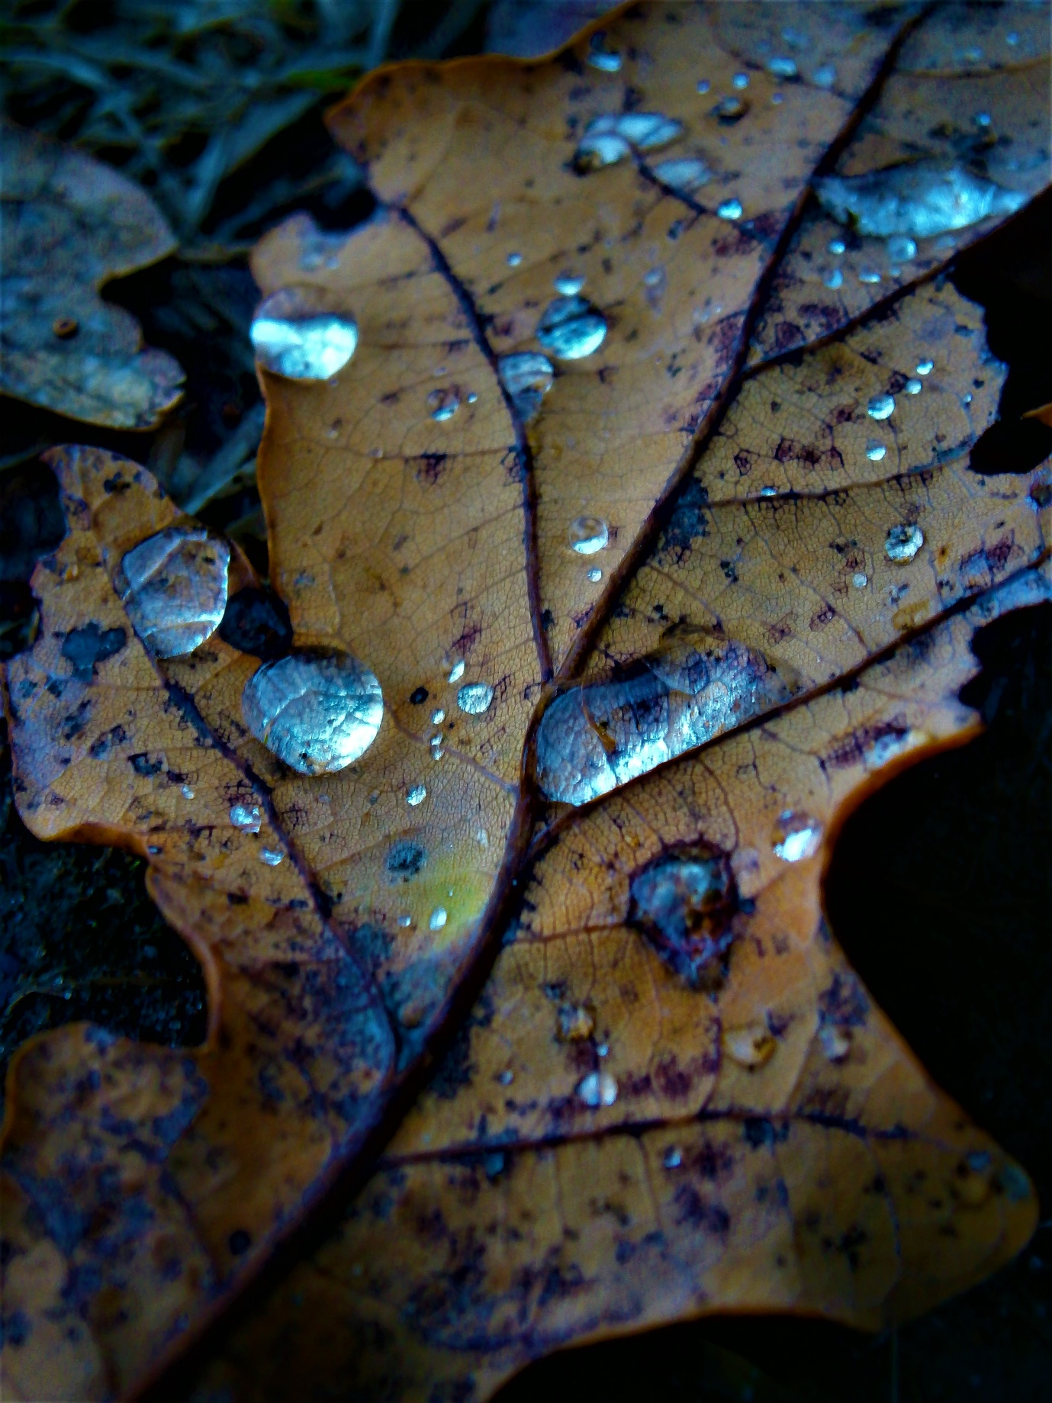

Magnification Sven Kretzschmar

The Magpie and the Sycamore Leaf

From my kitchen window
a long black finger flicks
up and down over the eve shoot,
balancing its dark belly a magpie
pierces its beak into dead leaves,
tosses them into the air,
they scatter, fall in a flutter, past the glass
in a dance of colour, yellow, sienna,
umber
without a sound
down onto the ground
down
in total surrender.
One gold sycamore leaf splayed on my path
and I hear the words of Kabir;
God is the breath inside the breath.

Attracta Fahy

The Artist
for Sacha
Her keen eye sees with sensibility
the bird, names the word,
calls the vision into her body;
black feathered cloak
fluid to flesh
speaks from within its image.
After she writes, she paints–
a crow emerges from her canvas,
alive where she lives.
She yields to the wings that enfold her–
knows nature does not stand outside
nature; it moves from within.

Attracta Fahy

To Spend Time with Love

Driving to the airport
on a long-ago spring day,
I was leaving you unwillingly,
it seemed the only way.
You promised, made a vow,
drew a future I could not see,
and the car radio suddenly played
the Louis Armstrong song:
“We Have All The Time In The World”
and I wept, because it was wrong.

There is never enough time free
in our world, for love, “only love”,
yet, grief and loss and absence
have no limits or boundary.
Ultimate spendthrifts they,
spinning their base coins of ruin,
and lest our pain should pall,
years later, an old poignant tune
re-opens a grievous wound
that has never quite healed at all.

Honor Duff

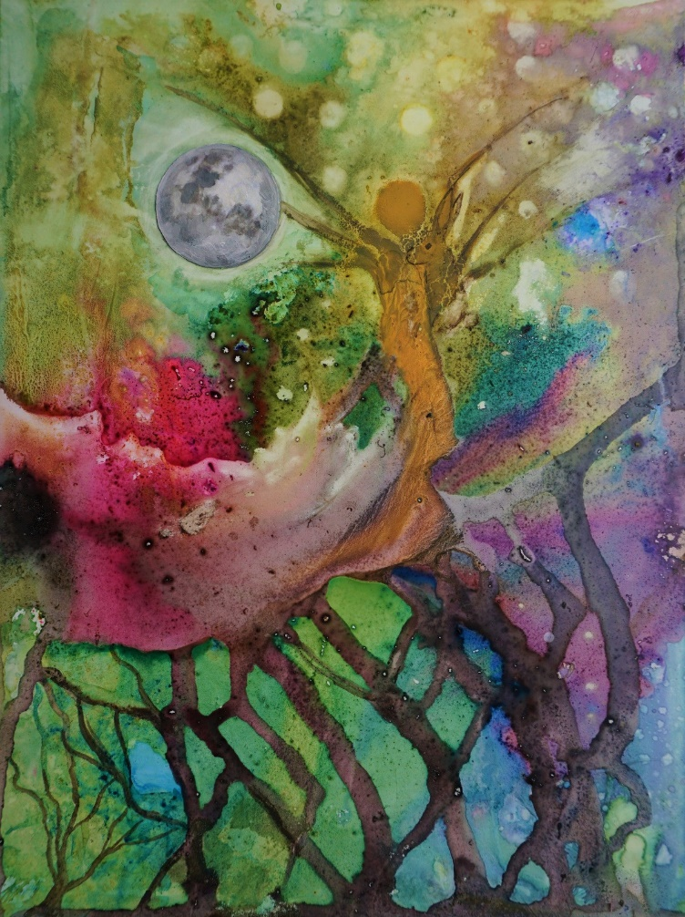

Bloom Ink, collage on yupo paper Anna Freyne

Seed Season

Held in hand, some sprinkled wonder.
Metaphor incarnate - hope, growth,
new beginnings. Great expectations,
lettering of nature.

Magic beans in miniature; beanstalks
called to mind. A flag, a banner, a subtle
unfurling. World within a whorl, within a week
periscopes of possibility.

Tiny seed, smaller than a full stop.
Curled in on itself like a dream,
at home in darkness,
hatching the future.

Siobhán Mc Laughlin

Tin box
(Those are pearls that were his eyes)

In the rusting tin box
the silky silt of memories
flows through my fingers.
The ghost of a red dress,
a dressing-gown, a trench-coat
a dark-blue blouse torn at the collar.
These two smooth ones –
his one and only suit
will be dark eyes,
white thread through four pinholes
for unseeing star-marked pupils,
like the pennies that women set
on closed eyes under the shrouds.

Cathy Fowley

After reading Jack Gilbert, 316

now
this man is scared, again
he needs to go back to the forest
naked
in the dark of the night
he walks away
out from his home, again
knowing he must
how his every breath depends upon this leaving
he counts the stars
one, two, three
he knows deep down they have already died
all he sees now is their burning light
and this is all the beauty he can bear

Fergus Hogan

Kathleen

In all the time known to me
never coloured her hair.
In many ways it defined her,
she wore it plain and simple.

When we’d meet, was always cheerful
and interested in what was happening,
telling funny stories or singing a song.
Once she did a jig upon the road,
recalling summer dances.

There were those who thought her innocent,
said that life did not fare well. She never
seemed to notice, if did, it was hard to tell.

Children came alive around her,
a rebel who fought for a cause;
their Caitlin, Acushla , Little Darling,*
good fun is what she was!

Liam McNevin

* The Irish for Kathleen is Caitlin which means Little darling.

Sunday

It is late, and you still type your notes
for the day; you ate some gluten, a little egg.

Your suitcase sits by the door;
the guestroom has only enough space for one.
Sorrell lies between us on the lounge.
She was not sick today. I hear blackbirds,
and the hum of the fridge.

You haven’t eaten well lately; your thyroid aches.

We are planning for the week, how many falafel,
tins of chickpeas, sweet potatoes, bananas we need.
And for the biscuits you will make as gifts:
flour, eggs, unsalted butter.

I have put on weight in England: ginger biscuits,
digestives, white bread. So much is familiar here,
and not.

That is what I like about England. The sedge warbler,
the change in weather, and all the different words
of English I haven’t heard before.

I didn’t expect anything from here,
not even to understand the accents, or the rain.

Ion Corcos

Spaghettification

when it goes dark
when the lights go out
when we fall into the dark
pit of oblivion

may we stretch
in gleeful fractal patterns
our debt to beauty
finally paid in full
as we scatter luminous cells

a million fireflies singing
murmurations in harmonies
lucid and deep, the pulse
of galaxies holding the bass line
as we dissolve into song.

Carolyn Claire Mitchell

* Spaghettification: ‘(physics) the process by which (in some theories) an object
would be stretched and ripped apart by gravitational forces on falling into a
black hole’. Oxford Dictionary of English.

Breaking News:

May 16, 1968. Scottish surgeons in Edinburgh
have performed Europe’s first lung transplant.

Like a miracle of recycling, bold surgeons
at the Royal Infirmary in old Edinburgh
have given new life to a lad from the Isle of Lewis,
transplanting the pristine lung of a lass
killed in a car crash hours earlier!

It’s true, Dad—it’s just too bad
this historic breakthrough
has come a fortnight too late
to be of even passing interest to you
now that you’re too dead to give a damn.

Eugene Platt

Dublin’s Eye

A single shop sign starts to flicker,
Then another one just down the road.
One by one
The city begins to blink

Opening its neon eyes.
Dublin city at night,
with her stone angels and revolutionary saints.
Little fires everywhere,
Kept in glass jars in different colours.
Colour shines through an emerald prism.
The magic swirl and pattern of people,
The Irish tribalistic banging of drums,
Tin whistles and bagpipes raging,
And life suddenly shows its purpose against the dark.
Laughter has a rhythm and rhyme.
And I look out towards it all now,
At how we've craved for this moment.
To be in the present, in the human embrace
And to shower each other with talk and drink.

Well, do it quickly.
Do it before the city shuts its eyes again.

Victory Luke

Young Boy

I asked a girl out,
Then the sun fell down,
And my eyes saw stars
In the spooling skein of space,
Because I had not learned
That my own desires,
Although infinite,
Are not fruit
That falls from branches
Heavy under the sun,
But a violin plucked
Shivering out a melody
That sometimes rises
And sometimes falls
But is always contingent
On a shared sense
Of hunger,
Of volition,
And of need.

Oisín Breen

she wasn’t royalty, she was a woman

I cannot walk alone at night,
I hold my keys like claws.
I jump at every noise and light,
I cannot stop or pause.

My mother taught me to bite if I had to,
To kick and make myself difficult
Because men don’t want difficult girls,
And in that scenario, a difficult girl is good.

My school took us on a trip to Germany,
Our bus was followed by a group of men.
We were scolded for our shorts that night,
They measured our skirts every Friday then.

I must not leave my drink with a boy,
Even if he seemed kind or friendly
I wonder why boys and men
Are okay with being considered deadly?

But these rules are pointless, life seems to prove
As even girls who lived by the rules
Are robbed of their lives in brutal ways,
It is how it is, our stagnant reality stays.

Sarah was every one of us,
Sarah did everything right.
Sarah did absolutely nothing at all
To deserve what happened that night.

What could she have done in all the world
To deserve what happened to her that night?

They held a vigil at a bandstand,
Lockdown couldn’t suppress this injustice.
I watched the women pinned to the ground
Torn apart, though none ever bared a fist.

I understand the times we live in.
I understand the dangers crowds hold,
But with conscience can you silence a peaceful protest
Of women who are (dying) of being Told?

Not a month later, lockdown still intact
The Prince died at home, of old age in bed.
Yet they gave the same message –
We must all grieve at home, they said.

Then they came in their hundreds and thousands,
Nobody stopped or questioned a soul.
Exceptions can be made for a beloved figure,
not for somebody nobody knows.

Oh but her family knew her,
and her boyfriend loved her.
Her friends will now never forget.
She was not loved widely, but she was loved deeply,
Yet they couldn’t mourn their dead

Why was this exception accepted?
What separates revolt from respect?
Because she wasn’t royalty, she was a just a woman,
What more needs to be said?

Jessica Anne Rose

Unwell

Slanty rooftops outside my glass pane look cubist and grey,
as television aerials sprout from the chimneys – Chinese letters against a milky sky
(it must be January...or November).
Only pigeons inhabit this space. Now and again a lone tabby appears from nowhere
– an extra in the scene. I look again, he’s gone.

I smoke Major, tapped three times on the pack, for luck.
I don’t leave here. I don’t want to.
- Three times.

Outside, I feel I’m on stage, I behave, obey rules I’ve never read.
The long walk home, my every step judged.
-‘Please like me.’

I make coffee stirring three spoons of sugar.
I rarely go out. I don’t like to.
- Three spoons.

The corner shop sells me cigarettes and milk, for other stuff I have to go farther.
I limit my trips, in then straight out, no messing; ‘Elvis has left the building.’
- ‘Straight’

When I pee I count to three before zipping up,
and tap the toilet seat three times.
- Three.

I look at television – The News. I understand it perfectly.
It all adds up, the jigsaw comes together.
- Messages received.

Whenever I see them in the clinic I behave myself, like I’m someone on a state visit,
(I’m always in the spotlight).
I suppose for them it’s work, for me, a social occasion. I notice everything.
- They’re all grinning at me.

I know it’ll happen again from out of the blue.
I’ll start to hear them once more: voices.
‘Listen’, I think then, ‘the bastard’s back!’

Jim Ward

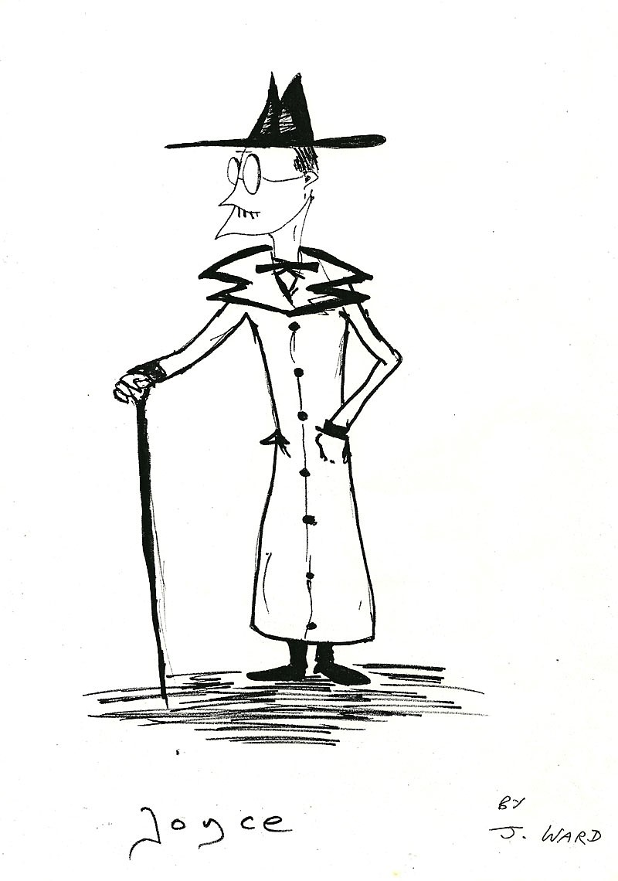

Mary, at the Gable End

Someone said
she’s either directing me towards
or turning me away
from Women!
That’s The Mary she’s talking about
of the Virgin status
on the other side of the kitchen wall
keeping life warm
with her solar powered halo.
I’d offer tea
if she moved,
a Ballinaspittle shift of her shoulders would do
but that’s blasphemous!
For she moves me
constantly
out the right side of my bed
and head
before I feel an inclination
to slide to the left
and fall.
Mary, we have things to talk about!
The kettle is on.
How do you like your tea?

Geraldine O’Sullivan

Still

I can taste those glass goodbyes that
spilled from my mouth and shattered
at once just like THAT at our feet

and although I know it shouldn't
the quiet yet rings in my ears like a
slow leak that leaves me emptying

so much so that now I go just to
stand on the sand and make sure
that the sky is still there, and yes

I know that my small hopes will
do me no good, but I would still
rather be dead than without them.

Lindsay McLeod

Life

Beauty bedazzles us.
A baby’s smile,
meadows shimmering in summer sun,
aroma of wild woodbine wafting towards us,
a full moon floating up.

Less easy to love ourselves,
aging brings illness and wrinkles.
But wholeness from within
mends a punctured ego,
embraces the torn heart.

Katherine Noone

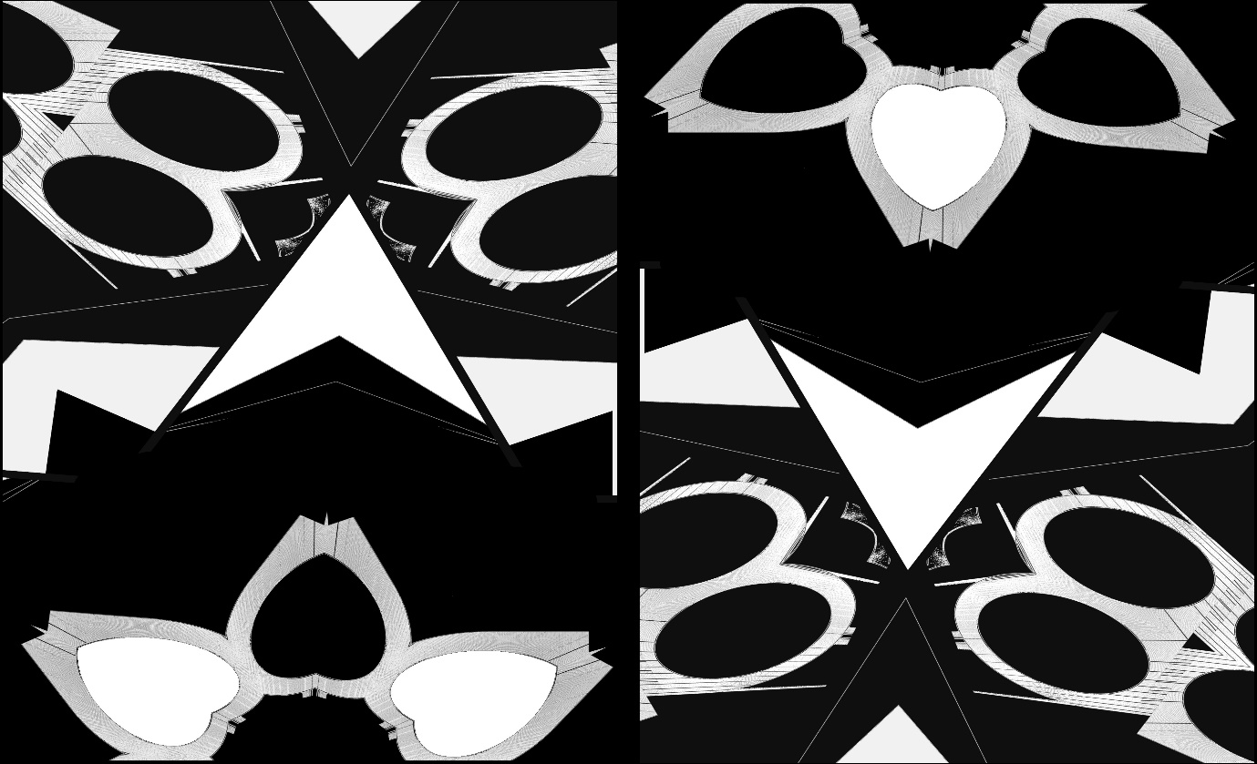

Light and Dark Hearts Edward Michael Supranowicz

Sour

She came in the summer on an airless day
when time dragged and flies beat themselves
senseless against the pane. Bored, you let
yourself be snagged by her red hair and lips; the rumour
of excitement in a dreary seaside town was just enough
to push you into action. Her saliva on an apple
that you shared drove you to distraction. July heat
made you feel weak and other things you wouldn’t
care to mention to your mother, but it was fine,
the face she showed to others was angelic, pure.
Lonely, miserable, I didn’t stand a chance against
the two of you. I wanted to be liked, that’s all,
but you were after something more. She knew it,
let you have a taste. It made my stomach turn.

Brian Kirk

Ode to Yellow
After Neruda

The yellow of toast.
Linguine with lemon butter sauce
eaten in the sunshine
is four times yellow.
Minion yellow. Pikachu yellow.
Simpsons yellow.
The pale yellow of insect blood.
The girl in the saffron dress
walking home from church
crosses over from the shade
to avoid the boys from the estate.
A yellow leaf on a cold day.
The halos of marigolds
and the sun, when we saw
the pollen come up.
Sulfurous lemon-yellow
of the evening sky.
Indian Yellow, made
from the urine of cows.
Orpiment. Tartrazine.
Eye-saver yellow.
Snake venom yellow.
Van Gogh with mouth full
of Chrome Yellow,
toxic as battery acid.
Vermeer Yellow.
Turner Yellow
Mondrian Yellow.
Winifred Nicholson Yellow.
Olafur Eliasson at Tate Modern:
monofrequency light
emits yellow that reduces
the viewers' spectral range.
In a meadow’s haze, yellow
is a buttercup held under
a tan chin.
As he climbs into bed with us
my son says, today is a yellow lamp

Kris Spencer

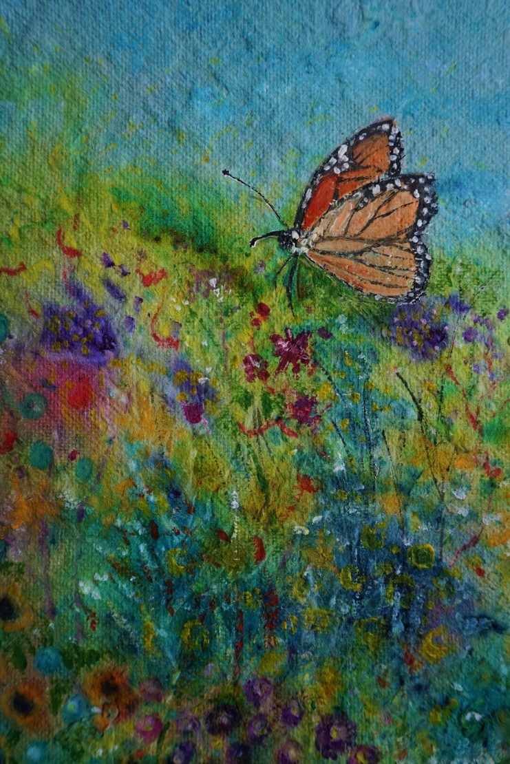

Summer Meadow Ink, acrylic on handmade paper Anna Freyne

Atelier des Lumieres, 11^{h} Arrondisement, Paris. 2018
(Workshop of Light)

Sparks of red rain splash telegraph poles,
rotating cogs squeeze women out of clouds,
they turn into powdered Rembrandt females
dressed in halos with pale pointed faces.
Across the concrete floor, a Caravaggio
depicts rearing horses, scenes of a battle.
On Dorian columns, exposed women
sidle up walls, cavort with angels.

Each immersed face becomes a piece of the puzzle
where priests march in tune to a waltzing Strauss.
Floating white lilies release lines of scrawl,
an abstract Klimt dashes the wall.
Celtic birds sing whistling notes,
a Cyclops’ eye blinks very slowly,
gliding goldfish sprout winking hands.
At the end, sheets of blue fade into a veil of tears,
coloured, arced rainbows disappear.
Darkness reigns on the concrete canvas.

Kate Ennals

Lists

They fill my pockets, my days,
These Honey-dos and
Honey do-nots:
Playlists,
Shopping lists,
Christmas lists,
Wish lists,
Bucket lists.

Other lists half-scratched:
Survivalist
Socialist
Journalist
Novelist
Conversationalist
Existentialist

Realist.

Listlessly,
they languish
at the bottom of my purse
like Times Square confetti
at 12:01.

Ellen Skowronski-Polito

Sleeping on the Beach

One moment before waking, it all made perfect sense,
but if there’s no return from where they’ve gone -
those cuttlefish dreams of rippling colours
that flashed by spontaneously, waving
hypnotising tentacles of hope –
I know that others will soon wash over me,
calming the billions of agitated grains
that choke my mind with ever-shifting sand:
soothing jellyfish visions floating past,
strange and charming as midnight seahorses,
escorting me back to the place I lost.

S.C. Flynn

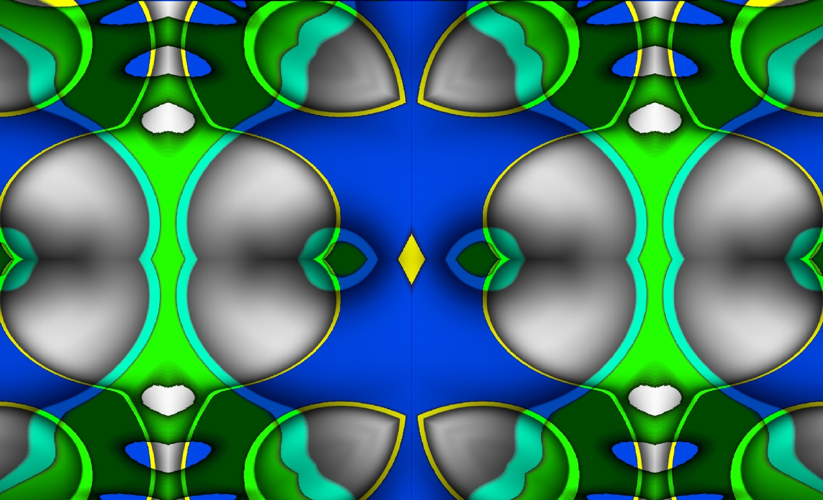

Blue and Green Dreams Edward Michael Supranowicz

Reefpoint

She came with a small scissors
in an envelope
She cut a lock of his hair
which she put in the envelope
which she sealed
which she gave to my brother's
partner for her and their son
to keep.

A nurse, perhaps,
friend or former lover
a stranger to me
her name gladly given
together with a firm embrace
I must know her, I think
but I don't
a sheet of gold leaf in the haze.
She speaks in his ear -
It is ok to go.
No, it isn't.
I cannot wave her off
She is here to help and knows better
than I.

Two ears
I should speak in the other,
but I can't.
Then, it is time for the hair cutting
and a garda from the local station.
I must make the formal identification
and confirm the known circumstances,
which I do.

Once they have gone
I sit with my brother.
I examine where the lock was cut
and carry on for a time
as if he is still with us.

Philip Davison

At Dollymount, skimming stones
(for Máirín, 1965-2021)

And we stay here, looking east
toward the seam of sky and sea,

dawn seeping, the lull
of a gauze horizon, its sudden unfurling.

You know, you don’t have to believe in anything,
except maybe the one thing of being

here,
the sky is a soft glow of belonging,

pearl-oyster filigree
threading the earth's edging,

beautiful now, as the light steps forward
just a little, and anything

could be true, even if only the moment
of this stone’s skimming-song,

touching and lifting
in slow-spinning motion,

hover-flow
hesitation,

its fearless glide catches
the light, each lingering

slide
a spiralling ripple, each lift,

uplifting,
and every throw, a moment

let go
from the heart of my hand,

purposefully
and for you.

Eithne Lannon

A Question (after Zora Neale Hurston*)

You say love is like the sea,
discovers itself as it hits the shore.
Some love must founder
in the deep-veined mouth of the marshes
in bright frills, snakes of water
Medusa’s face written in the fens
of Norfolk, of Andalusia
or in the oil-slick wake of a vessel
as big as New York; Ro-Ro, cruise ship
a ziggurat of container freight.

And when the sea rises
when Atlantic cities drink the ocean
and Pacific atolls breathe their last
how will love know itself?

Danica Ognjenovic

* ‘Love is like the sea. It’s a moving thing, but still and all, it takes its shape from the shore it meets, and it’s different with every shore.’

Distance Nothing More

I like to tell myself
that the ocean
between us
was our downfall,
when, in truth –
a truth more soft than hard,
though no less heavy -
we had drowned
each other long before
you boarded that plane
to take you to a better possibility,
distance nothing more
than a name to hang upon
an ending born
within our beginning,
the hearts we broke
to be together like a poison
infecting our veins

Edward Lee

Earth Tides

“No envy unless some atavistic scholar
Plodding that dry and tight-packed world discover
Some dusty relic that once could swim, a fossil”

—From No More Sea by Louis MacNeice

This land was once Atlantis
a narrow island drowning
with every newly made shore
fossils rolling through hot sand.

This land was once Atlantis
but there are Earth Tides too
the moon moves dry ground
in deep booms beneath my feet.

This land was once Atlantis
with a rich vocabulary
that spoke of sea in salt-wet surf
now silence is the dark weight I carry

into evening. I leave it to rest
on the hedgerow in the valley’s thin mist,
leave it jealous of the common newt
swimming breaststroke in the grass.

Sinéad McClure

High Seas

You are timber
and I am
inside you
and we are
out on the high seas,
riding
foam-saddled crests
of waves so tall
they disappear us
into clouds.

We reach the pinnacle
of a range
of scaled peaks
and I surf the top notes
like a barrel-
chested opera singer.

Your hull’s about to
bust a gut – ribs
straining under
pressure; oak carvel-
planks soaked inside
and out.

At your stern a rider-
less sea horse tumbles.

John D. Kelly

Robbed

Besides chattels of blanket, stool,
thermos flask, an umbrella pokes
out of his tartan bag for afternoons
of words and gestures,
mediated by double glazing.
This third season, his wife is curled
in a recliner chair. Occasionally,
her index finger and thumb pull
pearl buttons on her cardigan.
Though, for a time last year,
he recited some of her favourite
Emily Dickinson poems,
to eyes scrunching smiles –
WHO robbed the woods,
The Trusting woods?
Then the decree to close doors,
to the pain no vaccine can heal.

Marie Studer

Heaney and Frost

Peeking over Heaney and Frost
they are spied…book soil under fingernails,
un-alphabetising,
rainbowing spines.

Brusque boy with chewing gum palms and gold earrings to
rival Jack Sparrow. Feet on the desk.
Spit on the ceiling.
Curt with four letters. Like hardbacks,
his defenses only undress when somebody looks
past the sleeve.

Kawthar, comfortable in an adult’s quiet.
Respectful palms glaze covers,
she grazes pages with single syllables.
Not ready for Hemingway or Fitzgerald -
foraging for four letters:
H o m e

Dusty aisles barely notice him:
Baby face overwhelmed by circle frames,
he stutters and stumbles over each word
like rain that doesn’t quite reach the river.
Not ready to quit,
when nobody’s around, he’s the hero.

Olivia, most reverent of all.
Won’t let white rabbit rush her choice.
Under the paper weights
that caused men and women to fall
in love - she sponges up each potent drop, then distils her own.
One day, we’ll listen to her wisdom.

You teach more than a poet could:

To be vulnerable
To start slow
To get back up
To dream

Jessica Berry

On Ashford Hill

Cartwheeling along the ridge of the hill,
these acrobats with three long limbs
are slender farmers of the wind
who feed the ever-hungry grid.

Conjurers who, by sleight of arm,
light the bulb in my dark room
and leave me open-mouthed
and wondering how they do it.

Richard Devereux

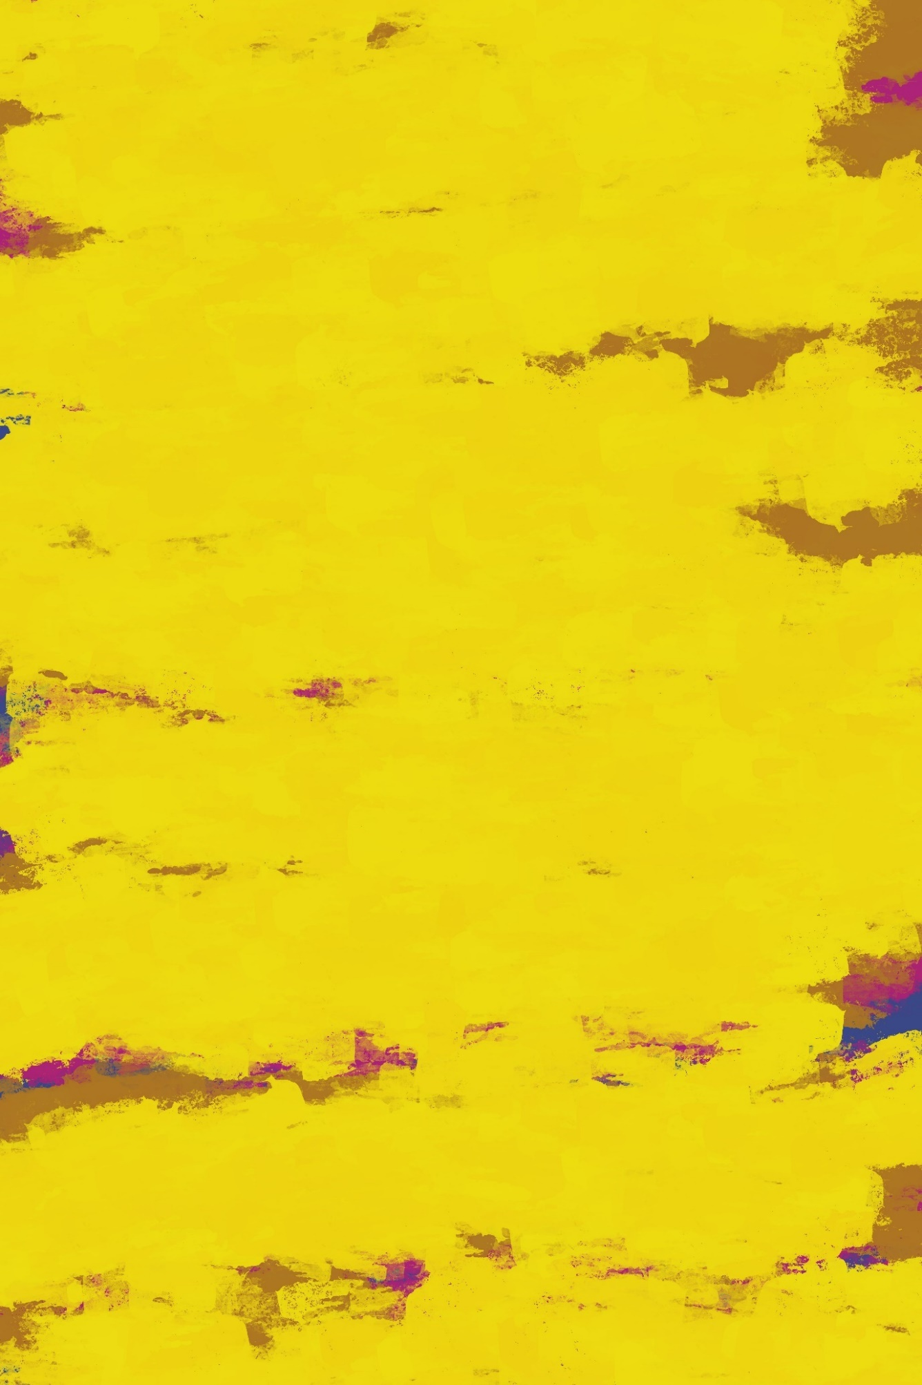

What The Day Asks For Edward Lee

Notes on Contributors

beam is a poet from Ireland. She has participated in workshops led by Kevin Higgins, read at Galway City's Literary Organisation event ''Over The Edge'' and has been published in Cabinet Of Heed, Broadsheet.ie, Impspired, Lothlorien Poetry Journal, Spilling Cocoa Over Martin Amis, WordCityLit, Ink Sweat And Tears & Open Skies. Recent work includes; surviving the pandemic and several disappointing sourdough loaves. She is becoming the kind of person who says the things you ''aren't supposed to say''. You can find more of her poetry @personalbeam on Instagram.

Jessica Berry grew up in Bangor, County Down. She is an English teacher at the Belfast Model School for Girls. Jessica enjoys writing songs, short stories, and poetry. During the first lockdown, she began sharing her poems on Instagram @jessicaruth.poetry. She is currently working on her first poetry collection, inspired by family stories passed down through generations. In 2021, Jessica was placed in Bangor’s annual poetry contest hosted by the Aspects Literary Festival.

A poet, part-time academic in narratological complexity, and financial journalist, Dublin born Oisín Breen's widely reviewed debut collection, Flowers, all sorts in blossom, figs, berries, and fruits, forgotten was released in March 2020. Breen has been published in a number of journals, including About Place, Northern Gravy, The Blue Nib, Books Ireland, The Seattle Star, Modern Literature, La Piccioletta Barca, The Bosphorus Review of Books, The Kleksograph, In Parentheses, The Madrigal, and Dreich.

Ion Corcos has been published in Cordite, Meanjin, Wild Court, The High Window, and other journals. Ion is a nature lover and a supporter of animal rights. He is currently travelling with his partner, Lisa. He is the author of A Spoon of Honey (Flutter Press, 2018).

Poet, cultural producer and harper, Emily Cullen, is also the inaugural Poet in Residence at the University of Limerick. Emily’s third collection, Conditional Perfect (Doire Press, 2019), was included in The Irish Times round-up of “the best new poetry of 2019.” She received an Arts Council Agility Award in 2021.

Philip Davison has published nine novels. Quiet City is his most recent work. He writes radio drama. He has written two television dramas and one stage play. He co-wrote Learning Gravity, a BBC Storyville documentary on poet and undertaker, Thomas Lynch. His poems have appeared in various journals. He is a member of Aosdána.

Christa de Brún is an academic and poet, she lectures in English Literature in WIT. Her poetry was shortlisted for the Anthology Poetry Prize 2020 and the Roscommon Poetry Prize at the Strokestown International Festival 2020. She was most recently published in The Ekphrastic Review, New Word Order and in the anthologies Addictions collated by Veronica Aaronson and Cathal Buí Selected Poems 2021.
Richard Devereux lives in Bristol, England. He writes passionately about Greece and the great outdoors. His most recent publications are in One Hand Clapping and Poetica.

Honor Duff, a native of Dublin, now lives in County Cavan. Her poems have been placed and commended in several competitions, including the Francis Ledwidge Awards, the Goldsmith Poetry Competition, the Red Line Festival and have been published in various journals including Boyne Berries, Crannóg, The Stony Thursday Book and Skylight 47.

Kate Ennals is a board member of Irish PEN/PEN na h'Éireann. Her published collections include At the Edge, Lapwing, Threads, Lapwing, and Elsewhere, Vole Imprint - November 21. Practically Perfect in Every Way, is forthcoming from Salmon, Spring 23.

Attracta Fahy, Psychotherapist, MAW NUIG ‘17. Winner of Trócaire Poetry Ireland Poetry Competition 2021. Irish Times; New Irish Writing 2019, Pushcart & Best of Web nominee, shortlisted for: OTE 2018 New Writer, Allingham Poetry competition both 2019 &’20, Write By The Sea Writing Competition 2021, Dedalus Press Mentoring Programme 2021. Her poems have been published in many magazines at home and abroad. Fly on the Wall Poetry published her bestselling debut chapbook collection Dinner in the Fields, in March’20.

S.C. Flynn was born in Australia of Irish origin and now lives in Dublin. His poetry has recently been published in Abridged, Cyphers, The Galway Review, SurVision and in issue 3 of Drawn to the Light Press.

Cathy Fowley holds an MA in Translation Studies and a PhD in Internet Research. Her autoethnographic research, often in poetry form, has been published in academic books and journals. She is a writer, poet, and facilitator of memoir writing who lives between Dublin and County Mayo.

Anna Freyne is a mixed media artist living in Ireland. She works with a variety of media including recycled materials in her work. Her artwork has featured in The Waxed Lemon, Kithe Journal and is forthcoming in The Jupiter Review, The Hyacinth Review and international magazine Cerasus. She received a BA in painting from the University of the Creative Arts UK. Anna is currently studying an MA in Art, Psyche and the Creative Imagination, in TUS Limerick School of Art and Design, Ireland. You can view more images of her work at www.instagram.com/artdreamspace.
Fergus Hogan’s poetry has been published in the Irish Times New Irish Writing, Channel, The Waxed Lemon, and among various journals and anthologies. In 2019 his chapbook, Bittern Cry, was published with Book Hub Publishing, while Crow Magic, was commended in the Fool for Poetry International Chapbook Competition. His poem Consent took first prize in Waterford’s inaugural spoken word and slam poetry competition in 2018.
John D. Kelly lives in Co. Fermanagh. His poetry has been widely published and highly commended in many magazines, anthologies and competitions. He has received several awards including the Listowel Short Collection Prize and the Desmond O’Grady International, both in 2020. His debut collection; The Loss of Yellowhammers was published by Summer Palace Press in 2020.
Brian Kirk is a poet and writer from Dublin. He has published a poetry collection After The Fall (Salmon Poetry, 2017) and a short fiction chapbook It’s Not Me, It’s You (Southword Editions, 2019). His poem “Birthday” won Poem of the Year at the Irish Book Awards 2018. He blogs at www.briankirkwriter.com.

Sven Kretzschmar hails from County Saarland, Germany. His poetry has been published widely in Europe and overseas, among other outlets with Poetry Jukebox in Belfast, in Writing Home, The ‘New Irish’ Poets (Dedalus Press, 2019), Poets Meet Politics (Hungry Hill Writing, 2020) Hold Open the Door (UCD Press, 2020), Voices 2020 (Cold River Press, 2020), Voices 2021 (Cold River Press, 2021) and 100 Words of Solitude (Rare Swan Press, 2021), in The Irish Times, Das Gedicht, Loch Raven Review, The Bangor Literary Journal, Studi Irelandesi, Culture Matters and South Florida Poetry Journal. He was awarded 1st prize in the ‘Creating a Buzz in Strokestown’ competition, shortlisted for the Allingham Poetry Award 2019, the Over the Edge New Writer of the Year 2019 and the Saolta Arts Annual Poetry Competition 2020. See more at: https://trackking.wordpress.com/ and Instagram: @sven_kretzschmar_poetry.

Eithne Lannon is a Dublin born poet living in Malahide. Inspired by the natural world, her poetry has been published at home and abroad in various contemporary literary journals and anthologies. Her first collection, Earth Music, published by Turas Press, was shortlisted for the Shine/Strong Award in 2020.
Edward Lee is an artist and writer from Ireland. His paintings and photography have been exhibited widely, while his poetry, short stories, non-fiction have been published in magazines in Ireland, England and America, including The Stinging Fly, Skylight 47, Acumen and Smiths Knoll. He is currently working on two photography collections: Lying Down With The Dead and There Is A Beauty In Broken Things. He also makes musical noise under the names Ayahuasca Collective, Orson Carroll, Lego Figures Fighting, and Pale Blond Boy. His blog/website can be found at https://edwardmlee.wordpress.com.

Victory Luke has been published in The Irish Independent and The Irish Times. She is a strong advocate for Climate Action and loves to partake in projects that spread awareness. A strong lover of words. Currently working on her first novella while still in college.

Sinéad McClure is a writer, radio producer and illustrator. Her writing is published on radio, and in anthologies, magazines and online journals including; Crossways Magazine, Meat for Tea, Live Encounters, Poethead, Drawn to the Light Press, The Cormorant, Dodging the Rain, A New Ulster, StepAway Magazine, Sonder Magazine, Tiny Spoon, The Poetry Bus, Vox Galvia, Ink Sweat & Tears, The Ekphrastic Review and RTEjr radio. Sinéad was the winner of the Ó Bhéal Five Word International Poetry Prize 2021.

Maeve McKenna is a poet living in Sligo, Ireland. Her poetry has been placed in several international poetry competitions, published in Mslexia, Orbis, Sand Magazine, Fly on the Wall, Channel Magazine among others and widely online. Maeve was a finalist in the Jacar Press Eavan Boland Mentorship Award 2020 and third in the Canterbury Poet of The Year in 2021. Her debut pamphlet will be published in February 2022, by Fly On The Wall Press.

Siobhán Mc Laughlin is a poet and creative writing facilitator from Co. Donegal. Her poems have appeared previously in Drawn to the Light Press, The Honest Ulsterman, The Ekphrastic Review, The Waxed Lemon, Bealtaine, The Poetry Village and more. Find her on Twitter: @siobhan347

Lindsay McLeod trips over the offing every morning. He has started messing about with words again lately. You might think he would know better by now, but oh no.

Liam McNevin is part of the Tallaght based, Virginia House Creative Writers. His debut collection of poetry, Times Present & Past, published by Swan Press was launched July 2021 His poems have been published in Live Encounters, Flare, Boyne Berries, Pendemic, Red Line Festival book, Looking Up, 2019. His short stories, The Moment and Home were commended in the Johnathan Swift Annual Writers Competition 2019 and 2021. Other work has featured in Tallaght Soundings anthologies and Dublin South FM.
Clara McShane is an emerging writer from Dublin with a BA in Psychology. She has been writing for most of her life, and finds a sense of peace and balance from engaging with poetry and prose. Her work has been published in The Caterpillar Magazine.
Carolyn Claire Mitchell is originally from Dublin and now lives in Co. Mayo. She has had work published in Poetry Ireland Review and The Stony Thursday Book.

Katherine Noone’s first poetry collection Keeping Watch was published 2017. Her second collection Out Here was published in 2019, both by Lapwing Publications Belfast. Her poetry is published in magazines and journals in Ireland, U.K. Canada and U.S.A. She lives in Galway and attends the poetry workshop at Galway Arts Centre.

Danica Ognjenovic was born in London. Her father was originally from Croatia. She studied at York University (English and Related Literature) and has been writing poems for about ten years. She has variously worked as an arts journalist, gallery technician, for a theatre company, a contemporary dance company and a classical Indian dance organisation. Placed in National Poetry Competition (UK) 2013, top ten of first Rialto pamphlet competition (2017). Published in Rialto, Abridged, The Moth, Acumen 100, Honest Ulsterman, Ink Sweat & Tears.

BSc graduate from Bristol (1998) Geraldine O’Sullivan has been writing poetry for years, honing her skills on Bere Island in West Cork where she worked on her return to Cork in 2008. Not having written anything for years, Geraldine recently discovered a spark of creativity and inspiration whilst on a summer stint with a pal in Saltmills, Co. Wexford. It was here that one of her poems ‘Because I’m from Cork’ was included in a Diversity Exhibition and again more recently two of Geraldine’s poems were part of the Applefest in Clonmel Co. Tipperary in September, and Darkness Into Light at Clonacody House in Fethard Co Tipperary this November. Geraldine lives in Cork city.

Eugene Platt, an octogenarian striving to remain active, is a native of Charleston, South Carolina, where he lives with his Canadian-born wife Judith, corgi Bess, cats Finnegan and Maeve. In the Cold War he served as a paratrooper with the American army. Later he studied at Trinity College Dublin and was invited to read in the inaugural Dublin Arts Festival (1970) with Seamus Heaney and Brendan Kennelly. His 2020 collection Nuda Veritas was published by Revival Press. A poem of his in Drawn to the Light Press #3 was nominated for a Pushcart Prize.

Jessica Anne Rose is an eager young poet hoping to provide a place where people like her can see themselves reflected in her poetry. This has been something she has searched for in childhood and her teenage years. Jessica is very proud and honoured to have been published in Green Carnations/Glas Na Gile’s Anthology 2020, which included four of her poems, alongside twenty-four other queer Irish poets.

Barbara DeCoursey Roy an American poet from St Louis, Missouri. She has been published in Vox Galvia, Headstuff, Skylight 47, Pendemic, and Popshot Quarterly. With three other women, Barbara won the 2021 Dreich Alliance Chapbook competition for How Bright The Wings Drive Us.

Breda Wall Ryan is the author of In a Hare’s Eye, Shine/Strong Award 2016, and Raven Mothers 2018, both from Doire Press. She is working on a third collection and lives in Bray, Co.Wicklow.

Ellen Skowronski-Polito (MA, New York University) works for a bilingual children's book publisher. In 2018, she published a collection of translated poems, Landscapes with Donkey (Green Writers Press), chronicling the adventures of a flying donkey who takes off from his hillside to save the planet from ecological disaster.

Kris Spencer is a Headteacher, living and working in west London. His poems have been published internationally. A Fellow of the Royal Geographical Society, themes central to his work are sense of place and sense of self. Something he shares with every poet.

Jan Starkey taught English at the secondary school level and education courses at the college graduate level. Her poems have been published in the anthology, The Music of the Aztecs, edited by David B. Churchill, and Minimus, a literary journal. She likes to paint, take photographs, and create collages.

Marie Studer is a past winter of the Trocáire Poetry Ireland Competition, twice a winner in the Bangor Ekphrastic Poetry Challenge and shortlisted in the North West Words Poetry Competition. Her poetry has been published in The Stony Thursday Book, The Waxed Lemon, Drawn to the Light Press, Dreich, Bangor Literary Magazine, online and local anthologies.

Edward Michael Supranowicz is the grandson of Irish and Russian/Ukrainian immigrants. He grew up on a small farm in Appalachia. He has a grad background in painting and printmaking. Some of his artwork has recently or will soon appear in Fish Food, Streetlight, Another Chicago Magazine, The Door Is a Jar, The Phoenix, and other journals. Edward is also a published poet.

Ross Thompson is a writer from Bangor, Northern Ireland. His debut poetry collection Threading The Light is published by Dedalus Press. His work has appeared on television, radio and the Poetry Jukebox alongside a wide range of publications such as Dear Reader, Lunate, Neologism, One, Popshot and The Trouvaille Review. Most recently, he wrote and curated A Silent War, a collaborative audio response to the COVID-19 pandemic that has been adapted by Northern Ireland Screen into a series of short archival films. He is currently preparing a second full length book of poems.

Cheryl Vail has had poems published in Issue V Sonder Magazine, Issue 3 of The Waxed Lemon, and on Culture Matters website.

Jim Ward is published for poetry and stories in Irish and English in various publications. His play Just Guff won 'Best in the West' award at Galway Fringe Festival, 2017 and has toured nationally including Town Hall Studio, Galway, Kilkee Playwright Festival and Liberty Hall, Dublin as part of MayFest 2019. His poem 2016 Proclamation was runner-up in the Galway Bay FM/Thoor Ballylee Yeats Poetry Challenge 2017. Another poem Orange Sunset came 3rd in the Bobby Sands Creative Writing Contest, 2021. A second play Three Quarks was performed live via Zoom on February 2nd last, Joyce’s birthday, by The James Joyce Centre in Dublin. His memoir piece Begging from Beggars was published in The 32 Anthology, edited by Paul McVeigh, in 2021. He is seeking a publisher for Rednecks in Suburbia, his first novel finished during the lockdown and is also a published cartoonist.

https://drawntothelightpress.com

Twitter: @DrawnPress

Instagram: @drawntothelightpress

Facebook: @drawnpress22

Drawn to the Light Press is edited, designed, and produced by Orla Fay.

Cover design Luminous Journey by Anna Freyne.

The works included in this issue are copyright of the poets and artists ©2022 and may not be reproduced or changed in any way without the permission of the individual author.

Drawn to the Light Press is ©2022 of the editor. All rights reserved.

